**A Parallel Weighted ADTC-Transformer Framework with FUnet Fusion and KAN for Improved Lithium-ion Battery SOH Prediction**

Chuang Chena,c, Yuheng Wua, Jiantao Shia,*, Dongdong Yuea, Dongzhen Lyub, Hongtian Chenc

*a College of Electrical Engineering and Control Science, Nanjing Tech University, Nanjing 211816, China*

*b College of Mechanical and Electrical Engineering, Wenzhou University, Wenzhou, 325035, China*

*c Department of Automation, Shanghai Jiao Tong University, Shanghai 200240, China*

∗Corresponding author.

*E-mail address:* sjt11@tsinghua.org.cn (J. Shi).

**摘要：本文围绕锂离子电池健康状态（SOH）预测中局部与全局特征的提取与融合展开深入研究，提出了一种新颖的并行加权架构——ADTC-Transformer。该架构结合了自适应膨胀时间卷积（ADTC）与Transformer编码器，有效捕捉并平衡局部与全局依赖，通过加权融合机制实现特征贡献的动态优化。此外，传统U型网络（Unet）通过引入特征金字塔网络（FPN）得到改进，形成FUnet模块，显著增强了多尺度特征的融合与利用能力。在此基础上，引入Kolmogorov-Arnold网络（KAN）作为最终预测模块，充分发挥其在高维特征复杂性建模方面的优势。实验结果表明，所提出方法在NASA、CALCE和WRBD等数据集上显著提升了预测精度，尤其在锂离子电池SOH的长期预测中表现卓越，为电池健康管理与性能优化提供了有力支持。**

**Abstract: This study delves into the extraction and integration of local and global features for lithium-ion battery State of Health (SOH) prediction, proposing an innovative parallel weighted architecture—ADTC-Transformer. This framework combines Adaptive Dilated Temporal Convolution (ADTC) with a Transformer encoder to effectively capture and balance local and global dependencies while dynamically optimizing feature contributions through a weighted fusion mechanism. Additionally, the traditional U-shaped network (Unet) is enhanced by incorporating a Feature Pyramid Network (FPN), forming the FUnet module, which significantly strengthens the fusion and utilization of multi-scale features. Building on this, the Kolmogorov-Arnold Network (KAN) is introduced as the final prediction module, leveraging its strength in modeling the complexity of high-dimensional features. Experimental results demonstrate that the proposed method markedly improves prediction accuracy across NASA, CALCE, and WRBD datasets, excelling particularly in long-term SOH prediction for lithium-ion batteries. This provides robust support for battery health management and performance optimization.**

**关键词——锂离子电池、SOH预测、Transformer、多尺度特征提取、特征融合。**

**Keywords: Lithium-ion batteries, SOH prediction, Transformer, multi-scale feature extraction, feature fusion.**

**1简介**

锂离子电池以其优异的能量密度、长使用寿命和低自放电率广泛应用于便携式设备、电动汽车以及可再生能源储能系统(Zhang et al., 2023)。然而，随着循环次数的增加，电池性能会逐步退化，因此，预测电池的健康状态（SOH）对于提高电池的利用效率和运行安全至关重要。传统方法通常分为基于物理模型、半经验模型和数据驱动模型三大类(Lipu et al., 2023)。

Lithium-ion batteries are widely used in portable devices, electric vehicles, and renewable energy storage systems due to their exceptional energy density, long lifespan, and low self-discharge rate (Zhang et al., 2023). However, as the number of charge-discharge cycles increases, the performance of these batteries gradually degrades. Therefore, accurately predicting the State of Health (SOH) of batteries is critical for improving their utilization efficiency and ensuring operational safety. Traditional approaches for SOH prediction can be categorized into three main types: physics-based models, semi-empirical models, and data-driven models (Lipu et al., 2023).

基于物理模型的方法通过复杂的偏微分方程描述电池内部的电化学机制(Wen et al., 2024; Vignesh et al., 2024; Chen et al., 2021; Lyu et al., 2020)，能够精确反映老化动力学，但其计算复杂性及参数化困难限制了实时应用。相比之下，半经验模型提供了较为简化的框架，利用实验数据建立模型(Singh et al., 2019; Cai et al., 2024)，但依赖于特定场景的实验数据，难以实现广泛泛化 。基于数据驱动模型的方法通常利用历史数据和老化趋势来估计电池健康状态(Lin, Tang, & Wang, 2015)。随着人工智能的发展，数据驱动模型已成为近年来的主流研究方向(Demirci et al., 2024; Chen, Jiang, & Ding, 2020; Chen et al., 2021; Chen, Tao, Shi, Shen, & Zhu, 2024)。它们通过对历史运行数据的分析，展现出较高的预测精度和扩展性 。

Physics-based models utilize complex partial differential equations to describe the electrochemical mechanisms within batteries (Wen et al., 2024; Vignesh et al., 2024; Chen et al., 2021; Lyu et al., 2020), enabling accurate representation of aging dynamics. However, their computational complexity and the challenges of parameterization limit their applicability in real-time scenarios. In contrast, semi-empirical models provide a simplified framework by building models based on experimental data (Singh et al., 2019; Cai et al., 2024), though their reliance on data from specific scenarios hinders broad generalization. Data-driven approaches, on the other hand, typically estimate battery health by leveraging historical data and aging trends (Lin, Tang, & Wang, 2015). With the advancements in artificial intelligence, data-driven models have emerged as the dominant research direction in recent years (Demirci et al., 2024; Chen, Jiang, & Ding, 2020; Chen et al., 2021; Chen, Tao, Shi, Shen, & Zhu, 2024). These models analyze historical operational data, demonstrating high predictive accuracy and scalability.

在数据驱动模型中，各种基准模型被广泛应用。循环神经网络（RNN）被视为最早探索序列建模的工具之一，凭借其记忆状态机制能够捕获时间序列特征。例如，Lu等(Lu et al., 2022)提出了一种基于RNN的SOH和RUL预测框架，将即将到来的电流计划和有限的初始容量-电压数据集作为输入，实现了对电池退化过程的建模。然而，RNN容易受到梯度爆炸和梯度消失问题的影响，限制了其预测精度。为此，研究者提出了改进版本，如Gated Recurrent Unit（GRU）(Zhang, Wang, Yuan, & Liang, 2022)和Long Short-Term Memory（LSTM）(Ren et al., 2020)。Ungurean等(Ungurean, Micea, & Cârstoiu, 2020)设计了一种基于GRU的在线SOH预测方法，并通过与LSTM的对比实验表明，两者在预测能力上表现出相近水平。进一步地，Ma等(Ma, Shan, Gao, & Chen, 2022)提出结合改进LSTM与健康指标（HIs）的模型，通过引入差分进化灰狼优化器（DEGWO）优化超参数，大幅提升了模型的准确性和鲁棒性。此外，BiLSTM（双向LSTM）凭借其对双向时间序列依赖的捕捉能力，在许多研究中得到了应用。例如，Li等(Li, Luo, Zhang, & Liu, 2023)结合增量能量分析（IEA）和BiLSTM，评估了电池退化与峰值特征之间的映射关系，构建了高精度的SOH预测模型。然而，尽管RNN及其变体能够有效捕捉时间序列依赖性，其计算复杂度较高，尤其在处理长时间序列时仍然面临一定的限制。

In data-driven models, various benchmark models are widely utilized. Recurrent Neural Networks (RNNs) are among the earliest tools explored for sequence modeling due to their memory-state mechanism, which effectively captures temporal features. For instance, Lu et al. (2022) proposed an RNN-based framework for SOH and Remaining Useful Life (RUL) prediction, using upcoming current schedules and a limited initial capacity-voltage dataset as inputs to model battery degradation processes. However, RNNs are prone to issues like gradient explosion and vanishing gradients, which limit their prediction accuracy. To address these shortcomings, improved variants such as Gated Recurrent Unit (GRU) (Zhang, Wang, Yuan, & Liang, 2022) and Long Short-Term Memory (LSTM) (Ren et al., 2020) have been developed. Ungurean et al. (2020) designed a GRU-based online SOH prediction method and demonstrated, through comparative experiments with LSTM, that both exhibit similar prediction capabilities. Furthermore, Ma et al. (2022) proposed a model combining an enhanced LSTM with Health Indicators (HIs), where hyperparameters were optimized using the Differential Evolution Grey Wolf Optimizer (DEGWO), resulting in significantly improved accuracy and robustness. Additionally, Bidirectional LSTMs (BiLSTMs) have gained popularity for their ability to capture bidirectional temporal dependencies. For example, Ma et al. (Li, Luo, Zhang, & Liu, 2023) integrated Incremental Energy Analysis (IEA) with BiLSTMs to evaluate the mapping relationship between battery degradation and peak characteristics, constructing a high-precision SOH prediction model. Despite their effectiveness in capturing temporal dependencies, RNNs and their variants often exhibit high computational complexity, which becomes a limiting factor, especially when handling long-term time series data.

同时，这些NN（Neural Network）模型并不适合处理数据中的空间模式。因此，卷积神经网络(CNN)作为捕获时间序列数据中的空间模式和短期依赖关系的解决方案出现了。例如，Valant等(Valant et al., 2019)通过1D CNN实现了退化模式的检测，而Durmus等(Durmus & Karagol, 2024)通过遗传算法优化CNN模型，在电池容量预测中取得了显著的精度提升。CNN在捕捉空间模式和短期时间序列模式方面表现出色，但其固定感受野限制了其对长时间依赖关系的建模能力，限制了其在需要捕获全局时间依赖场景中的表现。

Additionally, traditional Neural Network (NN) models are not well-suited for handling spatial patterns in data. As a result, Convolutional Neural Networks (CNNs) have emerged as effective solutions for capturing spatial patterns and short-term dependencies in time series data. For instance, Valant et al. (2019) utilized 1D CNNs to detect degradation patterns, while Durmus et al. (2024) optimized CNN models using genetic algorithms, achieving significant improvements in battery capacity prediction accuracy. CNNs excel in identifying spatial patterns and short-term temporal dependencies; however, their fixed receptive field limits their ability to model long-term dependencies. This constraint reduces their effectiveness in scenarios that require capturing global temporal dependencies.

为解决上述问题，时间卷积网络（TCN）作为CNN在时间序列领域的变体被引入。TCN对传统CNN进行了针对时间序列数据的优化改进，通过引入因果卷积，确保每个时间步的输出只依赖当前及之前的时间点，从而避免未来信息泄露问题，另外采用膨胀卷积，通过指数增长的感受野捕捉长时间依赖关系，同时降低了计算复杂度。这些改进使得TCN能够在保持并行计算效率的同时，高效建模长时间序列数据 。例如，Chen等(Chen et al., 2022)提出的AdTCN-BO模型结合贝叶斯优化，在SOH预测中实现了高精度。此外，Liu等(Liu et al., 2021)通过迁移学习结合TCN方法，有效提升了模型在多电池类型间的适用性 。尽管TCN在时间序列任务中的表现优异，特别是在捕捉长时间依赖关系和并行计算效率方面，相较于RNN和CNN有显著提升，但其局限性也逐渐显现。TCN在处理复杂多模态数据和多阶段退化特征时仍然存在一定的优化空间，特别是面对高维度特征的提取与融合时，其膨胀卷积机制难以有效处理特征间的全局依赖关系。此外，TCN在特征融合过程中，主要依赖于卷积的逐层传播，缺乏对全局特征动态建模的能力，这在高度复杂的时间序列任务中会影响预测性能。

To address the aforementioned issues, Temporal Convolutional Networks (TCNs), a variation of CNNs tailored for time series data, were introduced. TCNs enhance traditional CNNs for temporal modeling by incorporating causal convolutions to ensure that each output at a given time step depends only on the current and preceding time points, thus avoiding future information leakage. Furthermore, they leverage dilated convolutions with exponentially increasing receptive fields to capture long-term dependencies while reducing computational complexity. These improvements enable TCNs to efficiently model long time-series data while maintaining parallel computation efficiency. For instance, Chen et al. (2022) proposed the AdTCN-BO model, which integrates Bayesian optimization to achieve high accuracy in SOH prediction. Similarly, Liu et al. (2021) combined TCNs with transfer learning, effectively improving the model's applicability across various battery types. Despite their strong performance in time-series tasks, particularly in capturing long-term dependencies and ensuring computational efficiency compared to RNNs and CNNs, TCNs also exhibit limitations. Their capacity to handle complex multimodal data and multi-phase degradation features remains suboptimal. Specifically, the dilated convolution mechanism struggles to effectively address global dependencies among features in high-dimensional data. Additionally, TCNs primarily rely on layer-by-layer propagation during feature fusion, lacking the ability to dynamically model global features, which can hinder predictive performance in highly complex time-series tasks.

为解决这一问题，Transformer因其自注意力机制在捕捉全局依赖关系方面的独特优势，被广泛应用于电池SOH预测。Shen等(Shen et al., 2022)通过Transformer有效捕获复杂的全局时间依赖，显著提升了SOC预测的稳定性 。Han等(Han et al., 2023)设计的去噪Transformer网络（DTNN），结合残差学习和多头注意力机制，在复杂退化数据上表现出色。Zhao等(Zhao & Wang, 2024)针对多工况电池SOH预测的需求，提出了一种改进的Transformer架构，结合自注意力机制和图形表示技术，提高了模型对复杂电池数据的适应性和鲁棒性。然而，该研究依赖大量的训练数据，可能在数据匮乏场景下表现不佳。另外，Transformer对全局特征的过度关注可能忽略局部重要特征，同时其高计算复杂度和对大规模数据的需求限制了其在资源受限场景中的应用。此外，Transformer的输入特征建模依赖较为线性的嵌入处理，难以充分利用多模态数据中的多尺度特征。

To address these challenges, Transformers have been widely adopted for battery SOH prediction due to their unique advantage in capturing global dependencies through self-attention mechanisms. For instance, Shen et al. (2022) leveraged Transformers to effectively capture complex global temporal dependencies, significantly improving the stability of SOC predictions. Han et al. (2023) designed a Denoising Transformer Neural Network (DTNN) that combines residual learning with multi-head attention mechanisms, demonstrating outstanding performance on complex degradation datasets. Similarly, Zhao and Wang (2024) proposed an enhanced Transformer architecture tailored for multi-condition battery SOH prediction. By integrating self-attention mechanisms with graph representation techniques, their model achieved improved adaptability and robustness for handling complex battery data. However, these studies also highlight certain limitations. The reliance on extensive training datasets can hinder Transformer performance in data-scarce scenarios. Additionally, the strong emphasis on global features may lead to the neglect of locally significant features. Furthermore, the high computational complexity and substantial data requirements make Transformers less suitable for resource-constrained environments. Lastly, the modeling of input features in Transformers often depends on relatively linear embedding processes, which struggle to fully exploit the multi-scale features present in multimodal data.

为了在全局特征建模和多尺度特征融合方面进一步优化，U-Net及其变体凭借其独特的编码器-解码器结构和跳跃连接能力，为解决复杂特征提取问题提供了重要思路。例如，Fan等(Fan, Yang, & Hou, 2024)提出的混合注意力U-Net（MMAU-Net）通过多阶段退化分解策略，能够有效提取电池老化特征，从而显著提高了SOH预测的准确性。Song等(Song et al., 2024)进一步改进，提出动态重加权U-Net（EADRU-Net），通过引入边缘强调损失和上下文感知注意力机制，在捕捉细节特征方面展现了较强的能力。然而，尽管这些变体增强了U-Net的特定性能，其对全局时间序列依赖建模的能力有限，且较高的计算复杂度使其在大规模应用场景中的效率受到限制。此外，U-Net在处理多模态数据和高维复杂特征时缺乏灵活性，难以满足现代锂离子电池SOH预测中对全局特征与局部细节的平衡需求。

To further optimize global feature modeling and multi-scale feature fusion, U-Net and its variants, with their unique encoder-decoder structure and skip connection capability, provide valuable approaches for addressing complex feature extraction challenges. For instance, Fan et al. (2024) proposed the Mixed Attention U-Net (MMAU-Net), which utilizes a multi-stage degradation decomposition strategy to effectively extract battery aging features, significantly enhancing the accuracy of SOH prediction. Similarly, Song et al. (2024) introduced the Dynamically Re-weighted U-Net (EADRU-Net), incorporating edge-emphasis loss and context-aware attention mechanisms, demonstrating strong capabilities in capturing fine-grained features. However, despite these advancements in specific U-Net capabilities, their ability to model global temporal dependencies remains limited. Moreover, the relatively high computational complexity of U-Net variants reduces their efficiency in large-scale applications. Additionally, U-Net lacks flexibility when handling multimodal data and high-dimensional complex features, making it challenging to balance global feature representation with local detail extraction, a critical requirement for modern lithium-ion battery SOH prediction tasks.

与此同时，在这些基准模型的基础上，混合模型逐渐成为研究的热点。混合模型通过结合多种基准模型的优势，如RNN的时间序列建模能力、CNN的局部特征提取能力以及Transformer的全局依赖捕获能力，实现了性能的进一步提升。例如，Ren等(Ren et al., 2020)开发的Auto-CNN-LSTM模型结合自动编码器、CNN和LSTM，有效融合了深层特征和序列建模能力。Bao等(Bao et al., 2023)提出了一种结合CNN、改进LSTM（VLSTM）和维度注意力机制的混合模型，通过优化时序特征与关键特征权重，实现了锂离子电池SOH的高精度预测。此外，Wang等(Wang, Amogne, Chou, & Tseng, 2022)提出了一种结合BiLSTM和AM的混合模型，在六组锂离子电池数据上的实验结果表明，该方法在预测精度和鲁棒性上均有显著提升。相比于单一模型，混合模型在复杂场景中的适应性和鲁棒性更强，但也面临架构设计复杂、计算成本较高的问题。

Meanwhile, hybrid models have become a focal point of research, building on the strengths of benchmark models. By combining the advantages of various models—such as RNNs for temporal sequence modeling, CNNs for local feature extraction, and Transformers for capturing global dependencies—hybrid models achieve enhanced performance. For example, Ren et al. (2020) developed the Auto-CNN-LSTM model, which integrates autoencoders, CNNs, and LSTMs to effectively fuse deep features with sequence modeling capabilities. Similarly, Bao et al. (2023) proposed a hybrid model that combines CNNs, an improved LSTM variant (VLSTM), and dimensional attention mechanisms, achieving high-precision SOH prediction for lithium-ion batteries by optimizing temporal and key feature weights. Additionally, Wang et al. (2022) introduced a hybrid model that integrates BiLSTM and an attention mechanism (AM). Experimental results on six lithium-ion battery datasets demonstrated significant improvements in both prediction accuracy and robustness. Compared to single models, hybrid models exhibit greater adaptability and robustness in complex scenarios. However, they also face challenges such as increased architectural complexity and higher computational costs, which must be addressed for broader application.

针对以上这些问题，本文提出了一种新颖的混合模型，该模型的设计充分结合了多种现有模型的优势，并提出以下改进：通过自适应膨胀时间卷积（ADTC）模块，高效捕捉长序列依赖关系，兼具局部特征提取和全局特征识别能力；引入并行加权架构，通过平衡ADTC与Transformer的特征贡献，优化局部和全局特征的表示；进一步结合增强型U-Net（FUnet）模块，通过特征金字塔网络（FPN）提升多尺度特征的融合效率，降低计算复杂度；最后通过Kolmogorov-Arnold网络（KAN）建模高维特征的复杂关系并做出预测，从而显著提升了预测的精度和鲁棒性。

To address the aforementioned challenges, this paper proposes an innovative hybrid model that fully integrates the advantages of multiple existing approaches while introducing several key improvements. The model employs an Adaptive Dilated Temporal Convolution (ADTC) module to efficiently capture long-sequence dependencies, balancing local feature extraction and global feature recognition capabilities. A parallel weighted architecture is introduced to optimize the representation of both local and global features by balancing the contributions of ADTC and Transformer outputs. Additionally, the model incorporates an enhanced U-Net module (FUnet) that leverages a Feature Pyramid Network (FPN) to improve the efficiency of multi-scale feature fusion while reducing computational complexity. Finally, a Kolmogorov-Arnold Network (KAN) is utilized to model the complex relationships among high-dimensional features and generate predictions, significantly enhancing the model's accuracy and robustness. These advancements collectively enable the proposed model to achieve remarkable improvements in prediction performance and reliability.

本文的主要贡献如下：

1. 设计了一种自适应膨胀时间卷积（ADTC）模块。本文提出的ADTC模块结合了膨胀卷积与时间卷积的优点，能够在捕捉长时间依赖关系的同时保持对局部特征的精准提取。与传统时间卷积网络（TCN）相比，ADTC通过自适应调整膨胀系数，进一步优化了感受野的动态扩展，从而提升了对多阶段退化特征和异构时间序列数据的适应能力。
2. 设计了一种名为ADTC-Transformer的并行加权结构，结合ADTC模块和Transformer编码器的特征输出。通过加权融合机制，模型能够动态调整局部与全局特征在最终表示中的权重，有效解决了传统方法中单一特征建模的不平衡问题，显著提升了特征表示的精确性和一致性。
3. 在传统U形网络（Unet）结构中引入特征金字塔网络（FPN）与全局平均池化，形成FUnet模块。通过多尺度特征的逐级提取与动态融合，模型有效提升了特征捕捉的全面性，特别是在处理高维复杂数据时表现出色。此外，该模块还通过简化网络结构，降低了整体计算成本，使得模型更适合工业级应用。
4. 引入Kolmogorov-Arnold网络（KAN）进行最终预测。KAN利用可学习的非线性权重函数有效建模融合后高维特征的复杂性与效率，从而提升预测精度。
5. 在NASA、CALCE和温州随机电池数据（WRBD）数据集上开展实验。WRBD数据集由本实验室采集和处理，包含标准模式下电池（A_001、A_003、A_004、A_006）的详细退化信息，进一步增强了所提模型的鲁棒性与可靠性。实验结果表明，所提模型在SOH预测的长期任务中表现尤为优异。

The main contributions of this paper are as follows:

1）A novel Adaptive Dilated Temporal Convolution (ADTC) module is designed, combining the strengths of dilated and temporal convolutions. This module captures long-term dependencies while ensuring precise extraction of local features. Compared to traditional Temporal Convolutional Networks (TCNs), the ADTC dynamically adjusts dilation rates, further optimizing the expansion of the receptive field and enhancing adaptability to multi-phase degradation features and heterogeneous time-series data.

2）A parallel weighted architecture named ADTC-Transformer is proposed, integrating the feature outputs of the ADTC module and the Transformer encoder. Through a weighted fusion mechanism, the model dynamically balances the contributions of local and global features in the final representation, effectively addressing the imbalance in single-feature modeling of traditional methods and significantly improving the precision and consistency of feature representation.

3）The FUnet module is introduced by integrating a Feature Pyramid Network (FPN) and global average pooling into the traditional U-Net structure. This enables hierarchical extraction and dynamic fusion of multi-scale features, enhancing the comprehensiveness of feature capture, particularly when handling high-dimensional complex data. Furthermore, the module simplifies the network structure, reducing computational costs and making the model more suitable for industrial applications.

4）The Kolmogorov-Arnold Network (KAN) is employed for final prediction. By leveraging learnable nonlinear weighting functions, KAN effectively models the complexity and efficiency of fused high-dimensional features, thereby improving prediction accuracy.

5）Experiments were conducted on the NASA, CALCE, and Wenzhou Random Battery Dataset (WRBD). The WRBD dataset, collected and processed by the authors' laboratory, includes detailed degradation information for batteries (A_001, A_003, A_004, A_006) under standard operating conditions, further enhancing the robustness and reliability of the proposed model. Experimental results demonstrate that the proposed model performs exceptionally well in long-term SOH prediction tasks.

接下来，第II节介绍了本文所提出的混合模型架构，包括ADTC、Transformer、FUnet、KAN模块的基本原理和具体训练流程；第III节基于NASA、CALCE及实验室采集的WRBD数据集进行实验验证，并对结果进行详细分析；第IV节总结了全文并提出未来研究方向。

Next, Section II presents the proposed hybrid model architecture, detailing the fundamental principles and specific training processes of the ADTC, Transformer, FUnet, and KAN modules. Section III validates the model through experiments conducted on the NASA, CALCE, and WRBD datasets (the latter collected in the authors' laboratory), providing a comprehensive analysis of the results. Finally, Section IV concludes the paper and proposes directions for future research.

**2方法论**

**2 Methodology**

**2.1总体框架**

**2.1 Overall Framework**

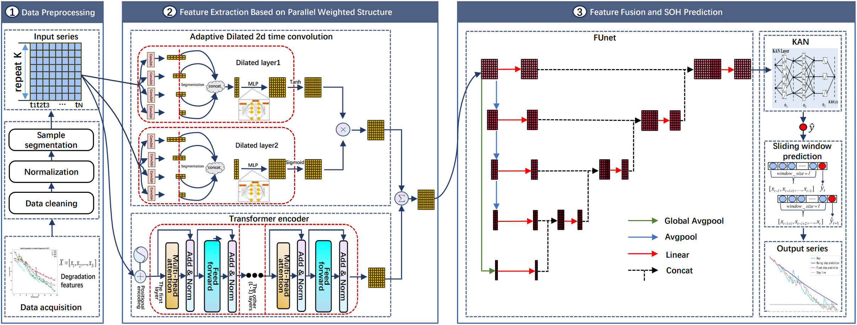

图1 带有FUnet融合和KAN的并行加权ADTC-Transformer框架示意图。

如图1所示，整个框架分为数据预处理、特征提取、模型训练与评估四个阶段。在预处理阶段完成数据归一化与训练集/测试集划分；在特征提取阶段并行运行ADTC与Transformer模块；在模型训练阶段，通过FUnet模块对加权的高维特征进行多尺度融合，通过KAN模块的非线性建模优化最终输出；最后在测试阶段完成单步预测与多步预测任务。总体框架的各模块之间高效协作，形成从原始数据到SOH预测的完整闭环。下文将详细介绍各模块的设计与实现。

As shown in Figure 1, the overall framework is divided into four stages: data preprocessing, feature extraction, model training and evaluation. During the preprocessing stage, data normalization and the division of training and testing datasets are completed. In the feature extraction stage, the ADTC and Transformer modules run in parallel. During the model training phase, the FUnet module performs multi-scale fusion of the weighted high-dimensional features, while the KAN module applies nonlinear modeling to optimize the final output. Finally, in the testing phase, both single-step and multi-step prediction tasks are conducted. The modules within the framework collaborate efficiently, forming a complete closed-loop process from raw data input to SOH prediction. The following sections provide a detailed explanation of the design and implementation of each module.

**2.2ADTC 模块**

**2.2 ADTC Module**

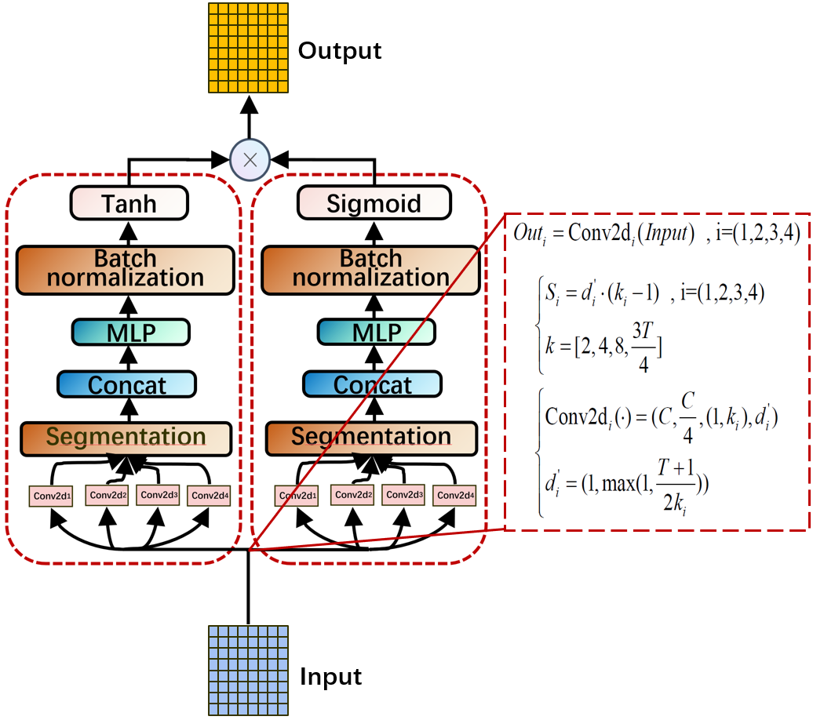

图2 自适应膨胀时间卷积（ADTC）模块结构图。

传统的时间序列卷积网络（Temporal Convolutional Network, TCN）因其高效的计算能力在时间序列建模中表现出色，其核心机制依赖于因果卷积（Causal Convolution）和膨胀卷积（Dilated Convolution），以实现时间依赖特征的捕捉。然而，随着实际应用场景的复杂化，传统TCN逐渐暴露出一些局限性。其卷积操作采用固定策略，例如指数增长的膨胀因子（1, 2, 4, 8）和固定卷积核大小（2, 3），这导致模型在处理多样化的时间特征时缺乏灵活性。具体而言，短期依赖特征可能被忽略，而过大的感受野又使长期依赖特征的关注力分散。此外，TCN无法根据输入序列的特性动态调整结构，显著限制了其对不同时间序列数据的泛化能力。

Traditional Temporal Convolutional Networks (TCNs) have demonstrated exceptional performance in time-series modeling due to their computational efficiency. Their core mechanisms, causal convolution and dilated convolution, enable the capture of temporal dependency features effectively. However, as application scenarios grow increasingly complex, traditional TCNs reveal certain limitations. Their convolution operations often rely on fixed strategies, such as exponentially increasing dilation factors (e.g., 1, 2, 4, 8) and predefined kernel sizes (e.g., 2, 3). This rigidity reduces the model's flexibility when dealing with diverse temporal features. Specifically, short-term dependencies may be overlooked, while an excessively large receptive field can dilute the focus on long-term dependencies. Furthermore, TCNs are unable to dynamically adjust their structure based on the characteristics of the input sequence, significantly limiting their generalization capability for varying time-series data.

针对这些不足，本文提出了一种自适应膨胀时间卷积模块（ADTC），模块结构如图2所示。该模块通过整合多分支结构、自适应膨胀策略和非线性激活机制，不仅能够细致地提取局部特征，还能灵活地建模全局依赖，显著提升特征表达能力。

To address these limitations, this paper proposes an Adaptive Dilated Temporal Convolution (ADTC) module, as illustrated in Figure 2. This module integrates a multi-branch structure, an adaptive dilation strategy, and nonlinear activation mechanisms, enabling it to extract local features with high precision while flexibly modeling global dependencies. These enhancements significantly improve the module's feature representation capabilities.

ADTC的设计核心是基于膨胀Inception结构的多分支卷积。在此结构中，不同的分支采用不同大小的卷积核（如2, 4, 8以及输入时间维度的3/4倍取整），并配以动态调整的膨胀因子。这种多分支设计在时间特征建模中表现出色：小卷积核分支能够捕捉局部时间步之间的细节特征，增强短期依赖的表达能力；而大卷积核分支则通过动态膨胀因子扩展感受野，有效捕捉长期依赖特征，从而建模全局趋势。膨胀因子的动态调整使模块能够根据输入序列长度灵活适应不同时间范围的特征建模需求。

The core design of the ADTC module is a multi-branch convolution based on a dilated Inception structure. Within this structure, different branches use convolution kernels of varying sizes (e.g., 2, 4, 8, and three-fourths of the input temporal dimension, rounded to the nearest integer) combined with dynamically adjusted dilation factors. This multi-branch design excels in time-series feature modeling: smaller kernel branches capture detailed features between local time steps, enhancing the representation of short-term dependencies, while larger kernel branches, aided by dynamic dilation factors, expand the receptive field to effectively capture long-term dependencies, thereby modeling global trends. The dynamic adjustment of dilation factors enables the module to flexibly adapt to different temporal ranges of feature modeling based on the length of the input sequence.

多分支设计可能因卷积操作的不同而导致时间维度的不一致。为此，ADTC采用动态时间对齐策略，通过截取最小时间长度来保证所有分支特征的一致性。对齐后的特征在通道维度上进行拼接，并通过两层全连接网络进一步优化特征的表达能力，从而确保多分支特征的有效融合。

The multi-branch design may result in temporal inconsistencies due to differences in convolution operations across branches. To address this, the ADTC module employs a dynamic temporal alignment strategy, which ensures consistency among all branch features by truncating them to the shortest temporal length. The aligned features are then concatenated along the channel dimension and further refined through a two-layer fully connected network, enhancing the expressiveness of the features. This ensures the effective fusion of multi-branch features for improved overall performance.

为提升特征筛选和表达能力，ADTC在模块末尾引入了非线性激活机制。这一机制由双膨胀卷积结构组成：一个膨胀卷积层后接双曲正切激活函数（tanh），作为过滤器，用于提取关键特征；另一个膨胀卷积层后接S型激活函数（sigmoid），作为门控机制，用于动态控制过滤器传递的信息量。最终的模块输出通过过滤器和门控机制逐元素相乘生成，实现了特征的动态筛选与信息流的高效传递。这种激活机制结合了tanh和sigmoid的优点，在复杂时间依赖的建模任务中表现出极高的灵活性和鲁棒性。

To enhance feature selection and representation capabilities, the ADTC module incorporates a nonlinear activation mechanism at its end. This mechanism is composed of a dual-dilated convolution structure: one dilated convolution layer is followed by a hyperbolic tangent activation function (tanh), acting as a filter to extract key features; the other dilated convolution layer is followed by a sigmoid activation function, serving as a gating mechanism to dynamically control the amount of information passed through the filter. The final module output is generated by element-wise multiplication of the filter and the gating mechanism, enabling dynamic feature selection and efficient information flow. This activation mechanism combines the strengths of both tanh and sigmoid, demonstrating exceptional flexibility and robustness in modeling complex temporal dependencies.

**2.3Transformer 模块**

**2.3 Transformer Module**

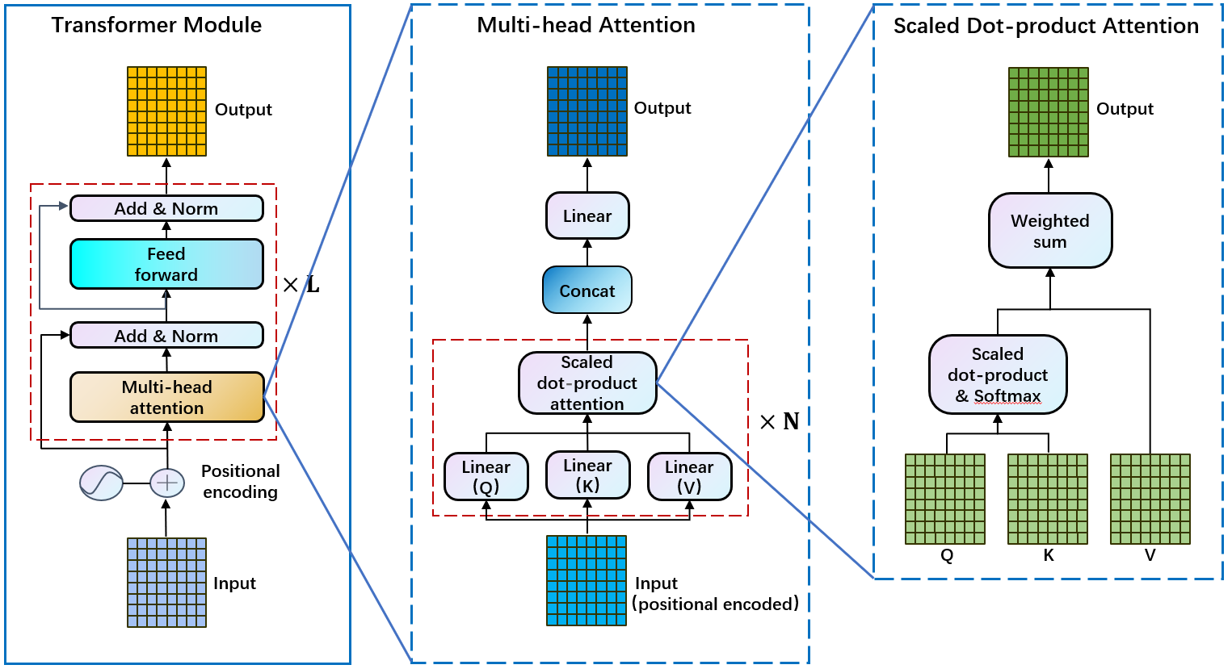

图3 Transformer编码器模块结构图。

Transformer作为一种以自注意力机制为核心的结构，近年来在序列建模任务中得到了广泛应用。其核心优势在于能够捕获时间序列中的全局依赖关系，并通过并行计算显著提升计算效率。本文采用了Transformer的编码器（Encoder）部分，通过堆叠多个编码器模块，结构如图3所示，实现对全局时间依赖特征的高效提取。编码器由多头注意力模块、Add & Norm模块以及前馈网络模块组成，其设计逻辑和功能如下。

As a structure centered on the self-attention mechanism, the Transformer has been widely applied to sequence modeling tasks in recent years. Its core advantage lies in its ability to capture global dependencies in time-series data while significantly improving computational efficiency through parallel processing. This study adopts the encoder portion of the Transformer, stacking multiple encoder layers to achieve efficient extraction of global temporal dependency features, as illustrated in Figure 3. The encoder consists of three main components: the multi-head attention module, the Add & Norm module, and the feedforward network module. The design logic and functionalities of these components are as follows:

多头注意力模块通过结合位置编码与自注意力机制，有效挖掘输入序列特征之间的全局关系。首先，序列的位置信息通过正弦和余弦函数进行编码：

The multi-head attention module effectively uncovers global relationships among input sequence features by combining positional encoding with the self-attention mechanism. First, the positional information of the sequence is encoded using sinusoidal and cosine functions:

 （1）

其中，是输入序列中对象的位置，是在所属向量中的位置，表示Transformer模型输出嵌入空间的维度。

Where  represents the position of an object within the input sequence,  denotes its position within the corresponding vector, and  indicates the dimensionality of the embedding space in the Transformer model's output.

将位置信息添加到原始输入上，构成Transformer模型的多头注意力初始输入：

The positional information is added to the original input , forming the initial input for the multi-head attention mechanism of the Transformer model:

 （2）

其中，指第个特征样本作为输入，指输入对应的位置编码。

Where  represents the  feature sample as input, and  denotes the positional encoding corresponding to .

接着，输入特征通过多头注意力机制计算子特征之间的相关性，得到每个子头注意力的输出：

Next, the input features are processed through the multi-head attention mechanism to calculate the correlations between sub-features, resulting in the output for each attention head:

 （3）

其中，指子头注意力的映射函数，指第层编码器的输出，，，是Transformer模型中对于第层第个注意力子头的三个随机初始化的权重矩阵，为Transformer模型中编码器堆叠的层数。

Where  represents the mapping function of the attention head,  is the output of the  encoder layer, and , , and  are the three randomly initialized weight matrices corresponding to the  attention head in the  layer of the Transformer model.  denotes the number of stacked encoder layers in the Transformer model.

然后，对各子头的输出进行拼接并线性变换，形成多头注意力模块的输出：

Then, the outputs of all attention heads are concatenated and linearly transformed to form the output of the multi-head attention module:

 （4）

其中，为多头注意力的映射函数，为多头注意力的权重矩阵。

Where  represents the mapping function of the multi-head attention mechanism, and  denotes the weight matrix of the multi-head attention module.

多头注意力模块的输出通过Add & Norm层进行优化，以确保梯度稳定性并保留输入特征。具体操作包括将多头注意力的输出与原始输入相加，并进行层归一化操作：

The output of the multi-head attention module is optimized through the Add & Norm layer to ensure gradient stability and preserve the input features. Specifically, the process involves adding the output of the multi-head attention module to the original input, followed by layer normalization:

 （5）

其中，为多头注意力部分的输出，为原始输入即上一层编码器的输出，为层归一化操作。

Where  is the output of the multi-head attention module,  represents the original input, which is the output of the previous encoder layer, and  denotes the layer normalization operation.

在前馈网络部分，编码器采用两层线性变换网络，用于增强非线性建模能力。前馈网络的输出可表示为：

In the feedforward network section, the encoder employs a two-layer linear transformation network to enhance nonlinear modeling capabilities. The output of the feedforward network can be expressed as:

 （6）

其中，为前馈层的映射函数，为前馈层内置的激活函数的映射函数，和为线性层的权重矩阵，和为线性层的偏置项。

Where  represents the mapping function of the feedforward layer,  is the activation function used within the feedforward layer,  and  are the weight matrices of the linear layers, and  and  are the bias terms of the linear layers.

然后，再次通过Add & Norm层优化前馈网络输出:

Then, the output of the feedforward network is further optimized through an Add & Norm layer:

 （7）

其中，为前馈层的输出，为多头注意力层的输出，为层归一化操作。

Where  represents the output of the feedforward layer,  denotes the output of the multi-head attention layer, and  refers to the layer normalization operation.

经过上述操作，Transformer的编码器模块通过层层堆叠的编码器单元逐步提取全局时间依赖特征。每一层编码器的输出都会传递至下一层进行更高层次的特征建模，直到最后一层，即第层编码器的输出完成对全局时间序列特征的整合优化：

Through the above operations, the encoder module of the Transformer progressively extracts global temporal dependency features by stacking multiple encoder units. The output of each encoder layer is passed to the next layer for higher-level feature modeling. This process continues until the final layer, i.e., the LLL-th encoder layer, where the integration and optimization of global time-series features are completed:

 （8）

通过这种层层递进的结构，Transformer的编码器能够在全局建模与细节捕捉之间实现良好的平衡，为后续模块提供丰富且精准的特征表达。

Through this progressive structure, the Transformer's encoder achieves a well-balanced capability between global modeling and detail capture, providing rich and precise feature representations for the subsequent modules.

**2.4FUnet模块**

**2.4FUnet Module**

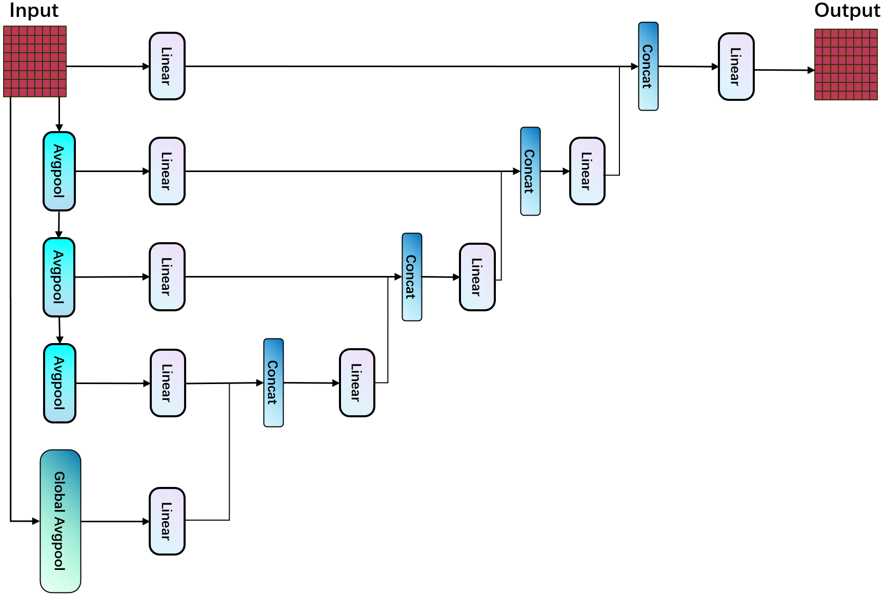

图4 FUnet模块结构图。

传统U-Net架构以其编码-解码结构和跳跃连接的特点，在结合上下文信息与细节特征方面具有明显优势。然而，在特定任务，尤其是长时间序列数据建模中，其表现受到以下限制：首先，U-Net通过局部卷积和池化操作完成特征提取，这使其在捕获全局特征时显得不足，特别是在处理复杂长序列依赖时。其次，其特征融合策略依赖于解码路径中的对应层级跳跃连接，这种方式无法充分结合深层次的全局趋势与浅层局部特征。最后，下采样过程中的池化操作尽管有助于压缩特征图，但也容易导致关键细节信息的丢失。

The traditional U-Net architecture, characterized by its encoder-decoder structure and skip connections, demonstrates clear advantages in combining contextual information with detailed features. However, for certain tasks, particularly long time-series data modeling, its performance is limited by the following challenges: First, U-Net relies on local convolution and pooling operations for feature extraction, which makes it insufficient in capturing global features, especially when handling complex long-term dependencies. Second, its feature fusion strategy depends on skip connections at corresponding levels in the decoding path. This approach fails to effectively integrate deep-level global trends with shallow local features. Finally, while the pooling operations during downsampling help compress feature maps, they also risk losing critical detailed information.

为克服这些局限性，本文设计了FUnet模块，结构如图4所示，并在以下几方面对传统U-Net进行了优化。首先，通过在最低层引入全局平均池化，FUnet能够有效捕获高维数据的整体趋势特征，这些全局特征通过跳跃连接传递到解码路径中参与特征重建过程，从而显著增强了对长程依赖的建模能力。其次，结合特征金字塔网络（FPN）的方法，FUnet通过平均池化逐层提取浅层、深层和全局特征，在上采样路径中对这些多尺度特征进行了拼接和线性变换的融合操作。这种多层次特征交互的设计平衡了不同尺度的信息，使得模型能够更高效地处理各种长度和分辨率的时间序列数据，同时显著提升特征图融合的效率。

To overcome these limitations, this paper designs the FUnet module, as illustrated in Figure 4, and optimizes the traditional U-Net in the following ways. First, by introducing global average pooling at the bottom layer, FUnet effectively captures overall trend features from high-dimensional data. These global features are transmitted through skip connections to the decoding path to participate in the feature reconstruction process, significantly enhancing the ability to model long-term dependencies. Second, by incorporating the Feature Pyramid Network (FPN) approach, FUnet progressively extracts shallow, deep, and global features using average pooling at each layer. During the upsampling path, these multi-scale features are fused through concatenation and linear transformations. This design of multi-level feature interaction balances information across different scales, enabling the model to efficiently handle time-series data of various lengths and resolutions while significantly improving the efficiency of feature map fusion.

此外，为了进一步降低计算复杂度，FUnet在设计中引入轻量化线性模块，分解部分卷积操作以适应长时间序列数据的处理需求。这种轻量化策略不仅提升了计算效率，还确保了对关键特征的有效捕获。

Additionally, to further reduce computational complexity, FUnet incorporates lightweight linear modules, decomposing certain convolution operations to accommodate the processing needs of long time-series data. This lightweight strategy not only enhances computational efficiency but also ensures the effective capture of key features.

基于这些改进，FUnet被置于ADTC和Transformer Encoder的并行加权模块后端。通过对局部与全局特征的加权融合特征图进行进一步的提炼与整合，FUnet成功弥补了传统U-Net的不足，为时间序列建模提供了更全面和高效的解决方案。

Based on these improvements, FUnet is placed downstream of the parallel weighted module integrating the ADTC and Transformer Encoder. By further refining and integrating the feature maps resulting from the weighted fusion of local and global features, FUnet successfully addresses the limitations of the traditional U-Net, providing a more comprehensive and efficient solution for time-series modeling.

**2.5KAN模块**

**2.5KAN Module**

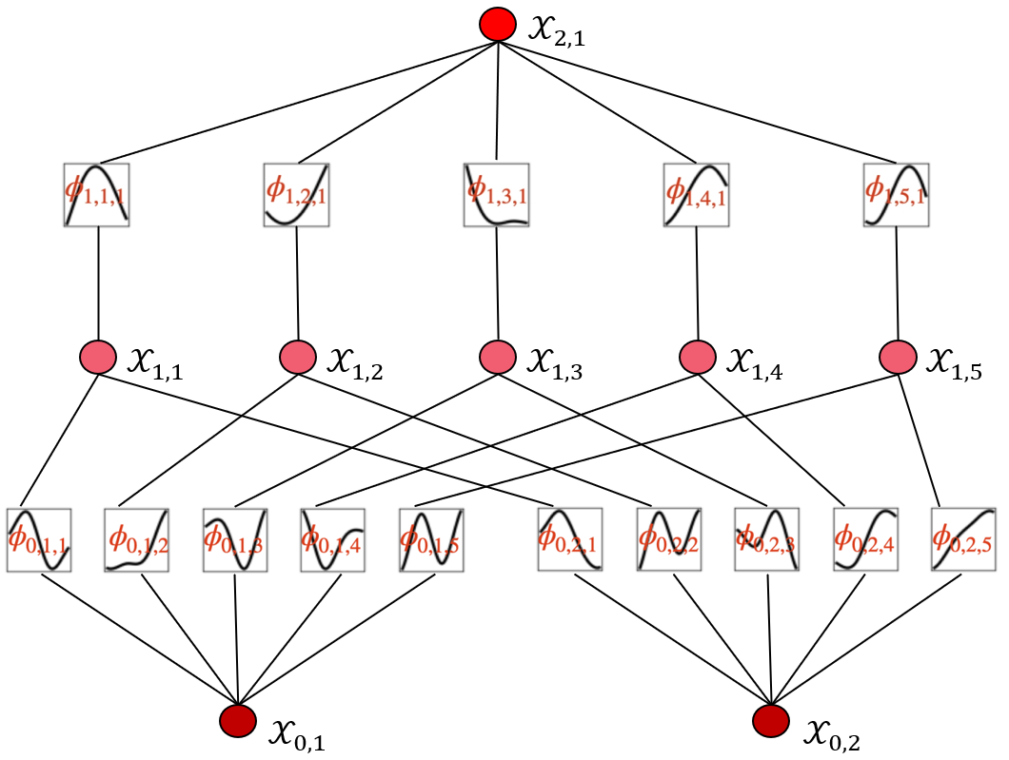

图5 KAN模块结构图。

KAN（Kolmogorov-Arnold Network）基于Kolmogorov-Arnold表示定理设计(Liu et al., 2024)，能够将任何连续的多维函数表示为若干单变量函数的嵌套组合，从而为复杂高维数据的处理提供理论支撑。在锂离子电池预测任务中，高维数据间常存在复杂非线性关系，KAN通过其特有的非线性激活和线性组合特性，可有效降低高维数据的复杂性，实现特征的高效建模与利用。因此，KAN模块在整个架构中被置于FUnet模块之后，作为最终预测模块，其结构如图5所示。

The Kolmogorov-Arnold Network (KAN), designed based on the Kolmogorov-Arnold representation theorem (Liu et al., 2024), can represent any continuous multi-dimensional function as a nested composition of several single-variable functions, thereby providing theoretical support for processing complex high-dimensional data. In lithium-ion battery prediction tasks, there are often complex nonlinear relationships among high-dimensional data. Leveraging its unique nonlinear activation and linear combination properties, KAN effectively reduces the complexity of high-dimensional data, enabling efficient feature modeling and utilization. As a result, the KAN module is placed after the FUnet module within the overall architecture, serving as the final prediction module. Its structure is illustrated in Figure 5.

KAN的总体公式如下：

The overall formula of KAN is as follows:

 （9）

具体而言，首先，KAN通过输入特征的分布动态生成网格节点位置，基于b样条基函数对每个输入特征通过网格节点实现插值，所有插值结果被线性组合以生成聚合结果，公式如下：

Specifically, KAN first dynamically generates grid node positions based on the distribution of input feature . Using B-spline basis functions, each input feature undergoes interpolation through the grid nodes, and all interpolation results are linearly combined to produce an aggregate result . The corresponding formula is as follows:

 （10）

 （11）

其中，为插值节点的位置，为b样条的度数，为可学习权值，为插值节点数。

Where  represents the position of the interpolation nodes,  is the degree of the B-spline,  is the learnable weight, and  is the number of interpolation nodes.

之后，对样条结果进行加权求和，得到所有输入特征的局部插值结果，结合非线性激活函数和偏置项，利用对进行全局非线性处理。公式如下：

Subsequently, the spline results are weighted and summed to obtain the local interpolation result  for all input features . This result is then combined with a nonlinear activation function and bias term, using  for global nonlinear processing. The corresponding formula is as follows:

 （12）

其中，为KAN模型中的全局非线性变换因子，表示插值后所有输入特征的局部插值结果之和，为非线性激活函数，为全局非线性变换层的可学习权值，为偏置项，表示偏移量，为全局函数层的节点数。

Where  represents the global nonlinear transformation factor in the KAN model,  denotes the sum of all the local interpolation results after interpolation for the input features,  is the nonlinear activation function,  is the learnable weight of the global nonlinear transformation layer,  is the bias term representing the offset, and  is the number of nodes in the global function layer.

KAN通过可学习的样条权值和激活函数参数，使其能够动态适配不同输入数据分布，实现了对并行加权结构与FUnet处理后的复杂高维特征的有效建模，确保最后的SOH预测结果具有更高的准确性与鲁棒性。

KAN, through its learnable spline weights and activation function parameters, is able to dynamically adapt to different input data distributions, effectively modeling the complex high-dimensional features processed by the parallel weighted structure and FUnet. This ensures a higher accuracy and robustness for the final SOH prediction results.

**2.6具体过程**

**2.6 Specific Process**

在这一部分，我们详细阐述了整个框架的具体过程，分为四个阶段：数据预处理与特征提取、模块特征融合、全局预测及训练与测试。

In this section, we elaborate on the specific process of the entire framework, divided into four stages: data preprocessing and feature extraction, module feature fusion, global prediction, and training and testing.

在预处理阶段，对原始健康状态数据预处理，得到ADTC模块的初始输入，通过逐渐增大卷积核  的膨胀卷积层,经过提取得到时间依赖的多尺度特征，卷积过程中不进行padding填充操作：

In the preprocessing stage, the raw health status data  is preprocessed to obtain the initial input  for the ADTC module. By gradually increasing the convolution kernel size  through the dilated convolution layers, time-dependent multi-scale features  are extracted, without using padding during the convolution process.

 （13）

 （14）

 （15）

其中，是原始健康状态数据，表示重塑后的，表示所属的实数张量形状，表示特征数量，表示序列个数，表示时间步长，,是通过不同卷积核  进行卷积后的四个多尺度特征,  表示二维卷积的映射函数，指卷积操作的步长，分别对应四个卷积核的大小，指二维卷积的输入通道数为，输出通道数为，指二维卷积核的大小，指膨胀因子；

Where  is the original health status data.  represents the reshaped .  represents the shape of the real tensor to which it belongs.  represents the number of features,  represents the number of sequences, and  represents the time step length.  is the set of four multi-scale features obtained by applying convolutions with different kernel sizes  to .  represents the convolution operation.  indicates the stride length of the convolution operation, while  corresponds respectively to , which are the sizes of the four convolution kernels. The kernel size  indicates that the input channel count for the 2D convolution is , the output channel count is ,  represents the dimensions of the 2D convolution kernel, and  is the dilation factor.

对不同卷积核进行卷积后，生成四个多尺度特征。为了统一多尺度特征的时间维度，以时间维度最短的特征为标准，进行一致化处理，截取长度为，得到四个截取后的多尺度特征：

After convolving with different kernel sizes, four multi-scale features  are generated. To unify the time dimensions of these multi-scale features, the shortest feature along the time dimension is used as the standard. The features are truncated to a length of , resulting in four unified multi-scale features :

 （16）

其中，指在时间维度上统一截取最后个时间步长的值，为中的最大值；

Where  indicates the last  time steps uniformly truncated along the time dimension, and  represents the maximum value among .

随后，这些特征沿通道维度拼接，恢复与ADTC初始输入相同的特征数量，得到拼接后的特征张量：

Subsequently, these features are concatenated along the channel dimension to restore the same number of features as the initial input  of the ADTC module, resulting in the concatenated feature tensor :

 （17）

接着，拼接后的特征张量 经多层感知机（MLP）处理生成第一个膨胀初始层的输出：

Next, the concatenated feature tensor  is processed by a Multi-Layer Perceptron (MLP) to generate the output of the first dilated initialization layer :

 （18）

接着，通过类似处理，得到第二个膨胀初始层DIL的输出。

Next, through a similar process, the output  of the second dilated initialization layer (DIL) is obtained.

随后，、分别通过Tanh激活函数和Sigmoid激活函数处理，再通过点积运算生成 ADTC 模块的最终输出：

Subsequently,  and  are processed through the Tanh and Sigmoid activation functions respectively, and then combined via element-wise multiplication to generate the final output  of the ADTC module:

 （19）

其中，表示tanh激活函数，表示Sigmoid激活函数，表示点积乘法。

Where  represents the Tanh activation function,  represents the Sigmoid activation function, and  represents the element-wise multiplication operation.

并行结构在将输入ADTC模块的同时，将输入到Transformer编码器模块，通过多头注意力和全连接层的处理生成全局特征表示：

In the parallel structure, while the input  is fed into the ADTC module, it is also fed into the Transformer encoder module. Through the processing of multi-head attention and fully connected layers, the global feature representation  is generated:

 （20）

其中，表示Transformer模块的流程函数，包含公式（1）~（8）。

Where  represents the process function of the Transformer module, which includes Equations (1) to (8).

接着，对 ADTC 模块与 Transformer 编码器模块的输出进行加权融合，生成 FUnet 模块的输入特征张量：

Next, the outputs from the ADTC module and the Transformer encoder module are combined through weighted fusion to generate the input feature tensor for the FUnet module:

 （21）

在 FUnet 模块中，构建特征金字塔结构，从第二层开始通过池化层提取特征，得到提取后的特征：

In the FUnet module, a feature pyramid structure is constructed, starting from the second layer to extract features through pooling layers, resulting in the extracted features :

 （22）

其中， 由计算公式得出，公式表达为：

Where  is obtained using the calculation formula , which can be expressed as follows:

 （23）

随后，各层特征经过线性层映射为中间特征：

Subsequently, the features from each layer  are mapped through a linear layer to intermediate features :

 （24）

随后，基于金字塔结构，从上到下依次进行中间特征在时间维度的拼接，并通过线性层生成下一层中间特征，重复此操作直至输出第1层特征：

Subsequently, based on the pyramid structure, intermediate features  are concatenated along the time dimension from top to bottom, and the next layer of intermediate features  is generated through a linear layer. This process is repeated until the feature  of the first layer is obtained:

 （25）

随后，把第1层的新特征当作多尺度特征的融合特征，经过线性层和reshape操作得到最终融合特征：

Next, the new feature from the first layer  is taken as the fused multi-scale feature , and after passing through a linear layer and a reshape operation, the final fused feature  is obtained:

 （26）

其中， 表示线性层的变换矩阵，且其是一个的变换矩阵；

Where  represents the transformation matrix of the linear layer, which is a transformation matrix of dimension .

最后，基于从 FUnet 模块获得的高维特征，采用 Kolmogorov-Arnold 网络（KAN）将融合特征转化为点预测结果，公式表达如下：

Finally, based on the high-dimensional features obtained from the FUnet module, the Kolmogorov-Arnold Network (KAN) is employed to transform the fused features  into point prediction results . The formula is expressed as follows:

 （27）

其中，指 KAN模块的流程函数。

Where  represents the functional process of the KAN module.

在测试阶段，经过预处理后的测试数据输入到训练好的模型中，通过滑动窗口累计预测点，生成完整的健康状态预测结果：

In the testing phase, the preprocessed test data  is fed into the trained model . Using a sliding window to accumulate predicted points, the complete health state prediction results  are generated:

 （28）

其中，指测试结果是包含个点数据标量，指滑动窗口从预测开始点到预测截止点（电池的记录最大放电循环数）的滑动步数。

Where  represents the test results,  is a scalar containing  data points, and  denotes the number of sliding steps taken by the sliding window from the start of prediction to the endpoint (the maximum recorded discharge cycle count of the battery).

在详细描述了模型的具体流程后，为了便于工程技术人员能够快速理解并实施该框架的核心算法设计，以下提供伪代码形式的简要流程总结。这种方式旨在以更加清晰、结构化的方式呈现关键步骤，使之便于直接应用于实际工程实践，同时也能为后续模型改进和扩展提供操作性参考，具体如算法1所示。

After detailing the specific workflow of the model, a concise summary of the core algorithm design is provided in the form of pseudocode to facilitate quick understanding and implementation by engineering practitioners. This approach aims to present the key steps in a clearer and more structured manner, making it directly applicable to real-world engineering practices while also serving as an operational reference for future model improvements and extensions. The pseudocode is outlined in **Algorithm 1**.

|  |
| --- |
| **Algorithm 1: Training and Testing Process of the Parallel Weighted ADTC-Transformer-FUnet-KAN Model** |
| **Input:**Lithium-ion battery operation datasets  Parameters after initialization：sequence length, sliding window size, batch size, learning rate, number of epochs, dropout rate, feature channels, kernel size, number of Transformer layers, hidden layer dimensions, and other structural hyperparameters.  **Output:**   * Trained Parallel Weighted ADTC-Transformer-FUnet-KAN model with determined weights. * Fixed-step prediction results: Predictions using a fixed-step strategy. * Moving-step prediction results: Predictions using a moving-step strategy. * Performance metrics: Relative Error (RE), Mean Absolute Error (MAE), and Root Mean Squared Error (RMSE).   **Training and Prediction Process:**  **1. Data Preprocessing**   * for each battery_name in the Battery_list do   + **Normalization**: Apply Min-Max normalization to the battery operation data.   + **Train-test split**: Divide the data into training and testing sets using the ratio train_ratio. * Store the preprocessed data as train_data (train_x,train_y) and test_data (test_x,test_y).   end for  **2. Model Initialization**   * Initialize the ADTC module, Transformer module, FUnet module, and KAN module, define the weight combination hyperparameters（e.g.,  and ）, and configure the optimizer (Adam) with the initial learning rate. |
|  |
| **3. Model Training**   * for epoch = 1, 2, ..., max_epochs do   + for each batch in train_data do     - **Feature Extraction:**       * Input the current batch into the ADTC and Transformer modules:     - **Weighted Fusion:**       * Fuse  and ：     - **Multi-Scale Feature Extraction and Fusion:**       * Input into the FUnet module:     - **Final Output Optimization:**       * Use the KAN module to generate the final prediction:       * Use a sliding window to accumulate predicted points and generate the health state prediction result .     - **Error Calculation and Backpropagation:**       * Compute the prediction error（e.g., MSE）：       * Update the model weights using the Adam optimizer.   **end for**   * + **Every 10 epochs:**     - Record intermediate performance metrics (e.g., RE, MAE, RMSE).     - Save the current model state.   **end for**  **4. Model Saving**   * Save the trained ADTC-Transformer-FUnet-KAN model.   **5. Model Testing**  **5.1 Single-Step Prediction**   * for each battery_name in Battery_list do   + Use the last feature_size points of test_x as the initial input.   + for step = 1, 2, ..., prediction_length do     - Predict the next point using the model, record the predicted value, and append it to test_x as part of the input sequence.   end for  end for  **5.2 Multi-Step Prediction**   * for each battery_name in Battery_list do   + Select the first feature_szie points (ground truth) from test_x to construct the input sequence.   + for step = 1, 2, ..., prediction_length do     - Predict the next point using the model and record the predicted value.   end for  end for   * 1. **Performance Evaluation** * Compare the predicted values  with the ground truth test_y to calculate the final performance metrics（Relative Error (RE)，Mean Absolute Error (MAE)，Root Mean Squared Error (RMSE)）。 |
|  |

**3实验与讨论**

**3. Experiments and Discussion**

本文的实验环境为Python 3.11.5解释器，使用Keras 3.3.3和TensorFlow 2.16.1深度学习框架搭建模型，并在Intel 64 Family 6 Model 191 Stepping 2处理器上进行试验验证。

The experimental environment is based on the Python 3.11.5 interpreter, with the model implemented using the Keras 3.3.3 and TensorFlow 2.16.1 deep learning frameworks. All experiments were conducted on an Intel 64 Family 6 Model 191 Stepping 2 processor.

使用“留一法”来进行训练和测试，划分方式如表1所示。通过四次迭代，每次保留一个电池数据用于测试，最终可以测试每个数据集的4节电池。将所有数据通过除以电池的额定容量来归一化到 [0, 1] 的范围内，并将归一化后的数据输入到训练好的模型中，通过反向模式自动微分和Adam优化器进行优化，使用的损失函数是均方误差（MSE）。

The "Leave-One-Out" cross-validation method was used for training and testing, with the division of datasets shown in **Table 1**. This approach iterates four times, each time reserving one battery dataset for testing, enabling evaluation on all four batteries in the dataset. All data were normalized to the range [0,1][0, 1][0,1] by dividing by the rated capacity of each battery. The normalized data were then input into the trained model, and the optimization was carried out using reverse-mode automatic differentiation with the Adam optimizer. The mean squared error (MSE) was employed as the loss function.

表1“留一法”划分数据的示意。

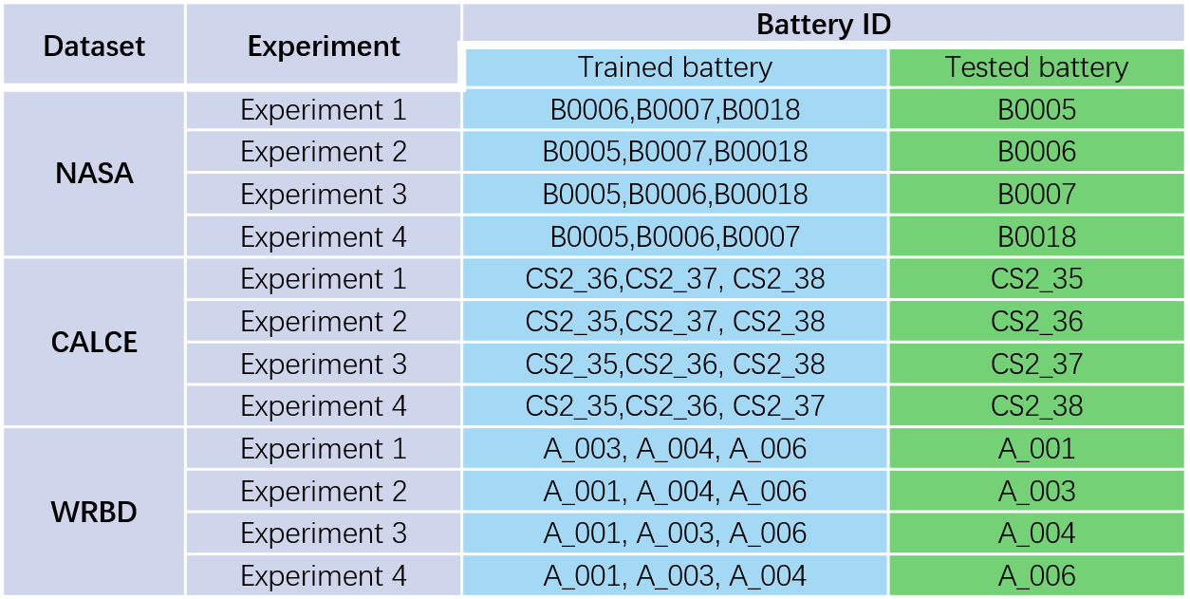

**3.1数据集介绍**

**3.1 Dataset Description**

为了验证所提模型的有效性，本文选用了NASA、CALCE和WRBD三大数据集，这些数据集提供了在不同实验条件下的电池退化信息。

To validate the effectiveness of the proposed model, three major datasets were utilized: NASA, CALCE, and WRBD. These datasets provide battery degradation information under various experimental conditions.

**NASA数据集**

**NASA Dataset**

NASA数据集包括18650锂离子电池（B0005、B0006、B0007、B0018）的测试数据。这些测试在24°C的室温条件下进行，采用恒流（CC）模式以1.5 A电流充电至4.2 V，随后切换至恒压（CV）充电，直到电流降至20 mA。放电过程在恒流2 A下进行，截止电压分别为2.7 V、2.5 V、2.2 V和2.5 V。电池寿命终止（EOL）标准为电池容量衰减至初始额定容量的30%，即从2 Ah降至约1.4 Ah。该数据集详细记录了不同工况下的退化趋势，是电池SOH预测领域中常用的基准数据集。具体如图6（a）所示。

The NASA dataset includes test data from 18650 lithium-ion batteries (B0005, B0006, B0007, B0018). These tests were conducted at a room temperature of 24°C using a constant current (CC) mode for charging at 1.5 A up to 4.2 V, followed by a constant voltage (CV) mode until the current dropped to 20 mA. The discharge process was performed at a constant current of 2 A with cut-off voltages of 2.7 V, 2.5 V, 2.2 V, and 2.5 V, respectively. The end-of-life (EOL) criterion for the batteries was defined as a capacity fade to 30% of the initial rated capacity, i.e., from 2 Ah to approximately 1.4 Ah. This dataset provides detailed records of degradation trends under various conditions and is a widely used benchmark dataset in the field of battery SOH prediction. The specific trends are illustrated in **Figure 6 (a)**.

**CALCE数据集**

**CALCE Dataset**

CALCE数据集由先进生命周期工程中心（CALCE）提供，包含四个电池（CS2_35、CS2_36、CS2_37、CS2_38）的数据。测试在1°C的控制温度下进行，充电采用恒流模式至4.2 V后切换至恒压充电，直至电流降至20 mA。放电以恒流模式进行，截止电压为2.7 V。EOL标准同样定义为额定容量下降30%，即从1.1 Ah降至约0.77 Ah。该数据集捕捉了在严格实验室条件下的退化特性，为SOH预测建模提供了宝贵的数据支持。具体如图6（b）所示。

The CALCE dataset, provided by the Center for Advanced Life Cycle Engineering (CALCE), includes data from four batteries (CS2_35, CS2_36, CS2_37, CS2_38). The tests were conducted under controlled conditions at a temperature of 1°C. Charging was performed in constant current (CC) mode up to 4.2 V, followed by constant voltage (CV) charging until the current dropped to 20 mA. The discharge process was conducted in constant current mode with a cut-off voltage of 2.7 V. The end-of-life (EOL) criterion was similarly defined as a 30% drop in rated capacity, i.e., from 1.1 Ah to approximately 0.77 Ah. This dataset captures degradation characteristics under rigorous laboratory conditions, providing valuable data support for SOH prediction modeling. The specific trends are illustrated in **Figure 6 (b)**.

**WRBD数据集**

**WRBD Dataset**

温州随机电池数据集（WRBD）(Lyu et al., 2024)由本实验室采集与处理，用以补充NASA和CALCE的公共数据集。WRBD数据集包含四个锂离子电池（A_001、A_003、A_004、A_006）的数据，这些电池均在标准的恒流/恒压协议下测试。充电过程以1C电流充至4.2 V后切换至恒压模式，直到电流降至0.05C。放电过程以1C电流至截止电压2.75 V完成。测试均在室温条件下进行，并定期记录容量衰减情况。EOL标准为容量从1.0 Ah降至约0.7 Ah。WRBD数据集提供了独特的、高质量的退化数据，增加了训练和评估过程的多样性与鲁棒性。具体如图6（c）所示。

The Wenzhou Random Battery Dataset (WRBD) (Lyu et al., 2024) was collected and processed by our laboratory to supplement the publicly available NASA and CALCE datasets. The WRBD dataset includes data from four lithium-ion batteries (A_001, A_003, A_004, A_006), all tested under standard constant current/constant voltage (CC/CV) protocols. The charging process used a 1C current up to 4.2 V, followed by a constant voltage phase until the current dropped to 0.05C. Discharge was conducted at a 1C current until a cut-off voltage of 2.75 V was reached. All tests were conducted at room temperature, with periodic recordings of capacity fade. The end-of-life (EOL) criterion was defined as a capacity reduction from 1.0 Ah to approximately 0.7 Ah. The WRBD dataset provides unique, high-quality degradation data, enhancing the diversity and robustness of the training and evaluation processes. The specific trends are illustrated in **Figure 6 (c)**.

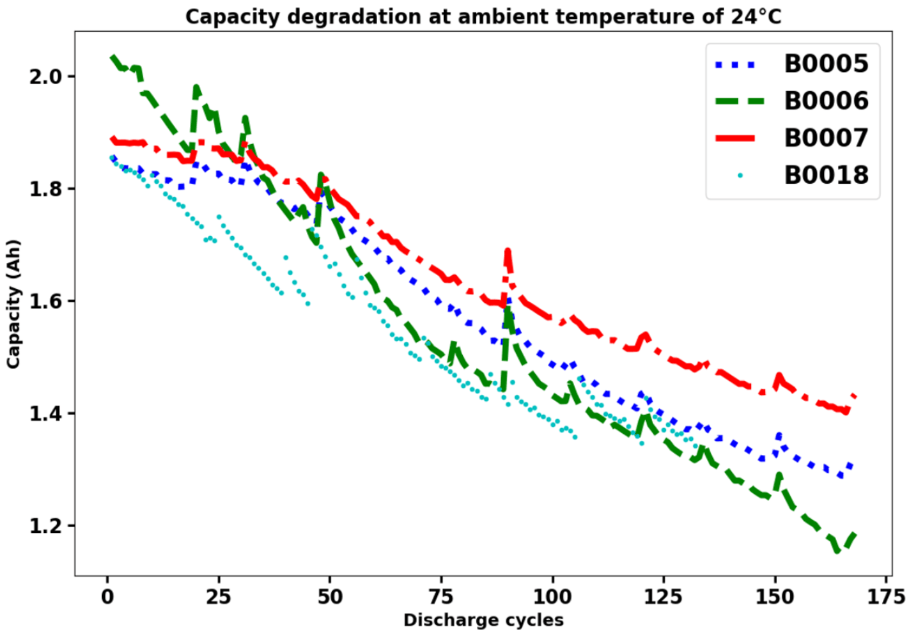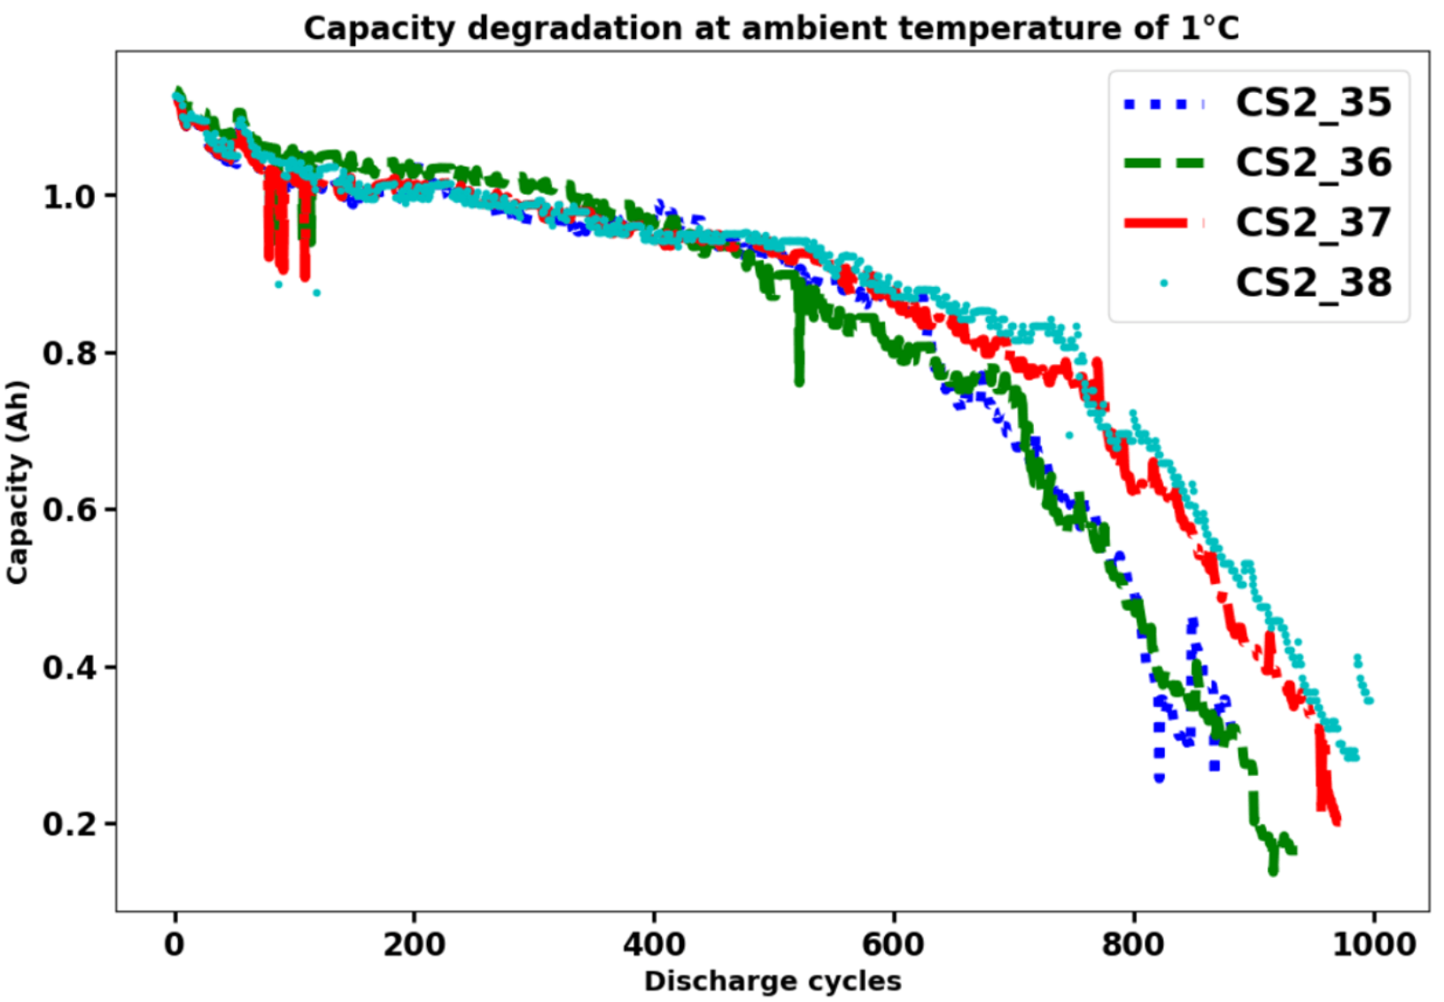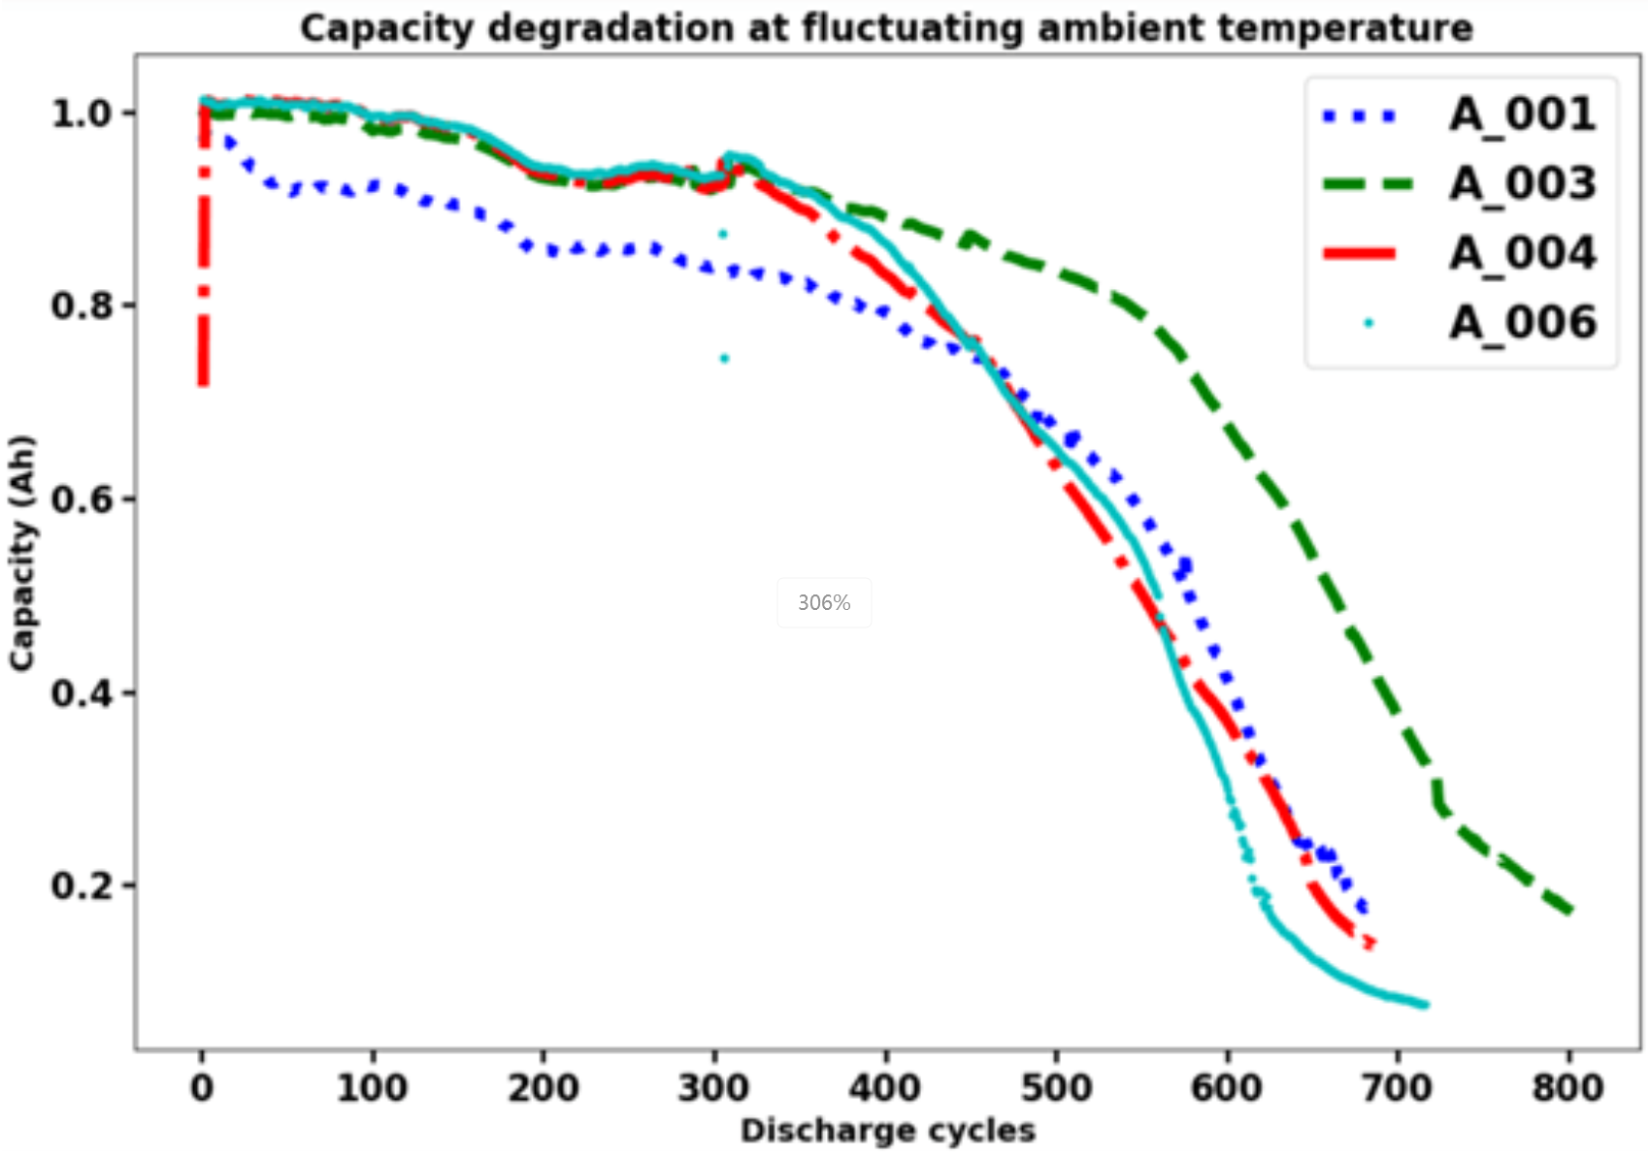

（a）NASA数据集。 （b）CALCE数据集。 （c）WRBD数据集。

图6 来自不同数据集的电池容量。

**3.2评价指标**

**3.2 Evaluation Metrics**

为了评估，本文将预测值重新转换回实际值，并将其与真实值进行比较。使用相对误差(RE)、平均绝对误差(MAE)和均方根误差(RMSE)作为评价指标。

To evaluate the prediction performance of the proposed model, three widely used metrics were employed: **Relative Error (RE)**, **Mean Absolute Error (MAE)**, and **Root Mean Squared Error (RMSE)**. These metrics are defined as follows:

 （29）

其中，表示在时刻估计的SOH；表示当前电池序列的时间点总数，表示序列中训练数据的结束时间点。

Where represents the estimated SOH at time ,  denotes the total number of time points in the current battery sequence, and  is the end time point of the training data in the sequence.

选择Unet、FUnet、FUnet+ADTC、FUnet+ADTC+TRM和完整模型（FUnet+ADTC+TRM+KAN）进行对比，构成消融实验。选择Dual-LSTM(Shi & Chehade, 2021)、CNN-GRU(Sun, Wang, Xiao, Peng, & Zhou, 2024)、DeTransformer(Chen, Hong, & Zhou, 2022)、TCN-ECANet-GRU(Xiang et al., 2024)、MEWOA-VMD and Transformer(Chen et al., 2024)模型与本文模型进行对比，构成对比实验。所有实验均重复5次取平均值，实验结果如图所示。

An ablation study was conducted by comparing the following models: U-Net, FUnet, FUnet+ADTC, FUnet+ADTC+TRM, and the full model (FUnet+ADTC+TRM+KAN). Additionally, comparative experiments were carried out by benchmarking against state-of-the-art models, including Dual-LSTM (Shi & Chehade, 2021), CNN-GRU (Sun, Wang, Xiao, Peng, & Zhou, 2024), DeTransformer (Chen, Hong, & Zhou, 2022), TCN-ECANet-GRU (Xiang et al., 2024), MEWOA-VMD, and Transformer (Chen et al., 2024). Each experiment was repeated five times, and the average results were reported. The experimental outcomes are presented in the following figure.

**3.3参数设置**

**3.3 Parameter Configuration**

在模型构建与训练过程中，超参数的选择和优化对性能有重要影响。本研究中，滑动窗口的大小固定设置为 1，训练轮数为 500。其余超参数均通过网格搜索法进行优化。特征通道数（）在集合 {1,2,4,8,16}中搜索,序列长度（）在集合 {8,16,32,64,128}中搜索，批次尺寸（）在集合 {8,16,32,64,128}中搜索，Transformer 层数（）在集合 {1，2，4，8，16}中搜索，注意力子头数（）在集合 {1，2，4，8，16}中搜索，隐藏层维度()在集合 {2，4，8，16，64}中搜索，学习率（）在集合 {0.0001,0.0005,0.001,0.005,0.01}中搜索，Dropout 比例（）在集合 {0.0001,0.0005,0.001,0.005,0.01}中搜索。各个数据集的最终寻优结果如表2所示。

The selection and optimization of hyperparameters play a crucial role in achieving optimal performance in the process of model construction and training. In this study, the sliding window size was fixed at 1, and the number of training epochs was set to 500. Other hyperparameters were optimized using the grid search method. The hyperparameters and their corresponding search ranges are as follows: feature channels () were searched within {1,2,4,8,16}, sequence length () within {8,16,32,64,128}, batch size () within {8,16,32,64,128}, number of Transformer layers () within {1,2,4,8,16}, number of attention heads () within {1,2,4,8,16}, hidden layer dimension () within {2,4,8,16,64}, learning rate () within {0.0001,0.0005,0.001,0.005,0.01}, and dropout ratio () within {0.0001,0.0005,0.001,0.005,0.01}. The final optimized hyperparameters for each dataset are shown in **Table 2**.

表2不同数据集的超参数寻优结果。

|  |  |  |  |  |  |  |  |  |  |
| --- | --- | --- | --- | --- | --- | --- | --- | --- | --- |
| Model | Dataset | hyper-parameters | | | | | | | |
|  |  |  |  |  |  |  |  |
| Proposed Model | NASA | 16 | 16 | 128 | 3 | 8 | 16 | 0.005 | 0.0001 |
| CALCE | 16 | 64 | 128 | 2 | 8 | 8 | 0.003 | 0.0001 |
| WRBD | 16 | 64 | 128 | 2 | 8 | 8 | 0.005 | 0.0001 |

**3.4单步预测与多步预测**

**3.4 Single-Step and Multi-Step Predictions**

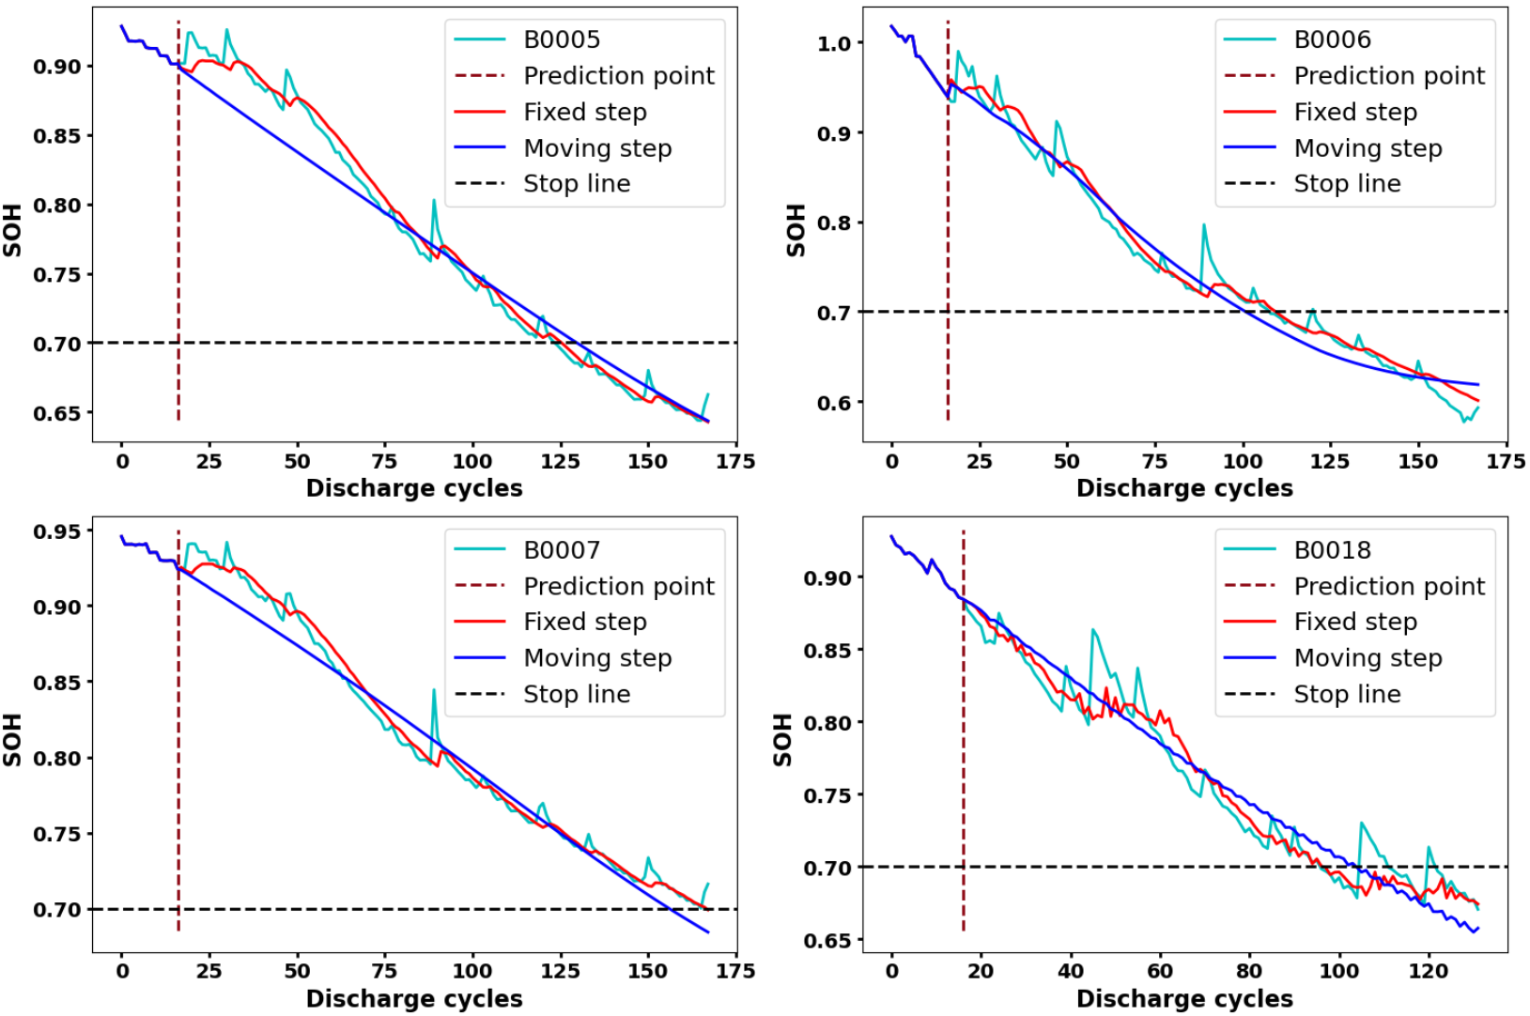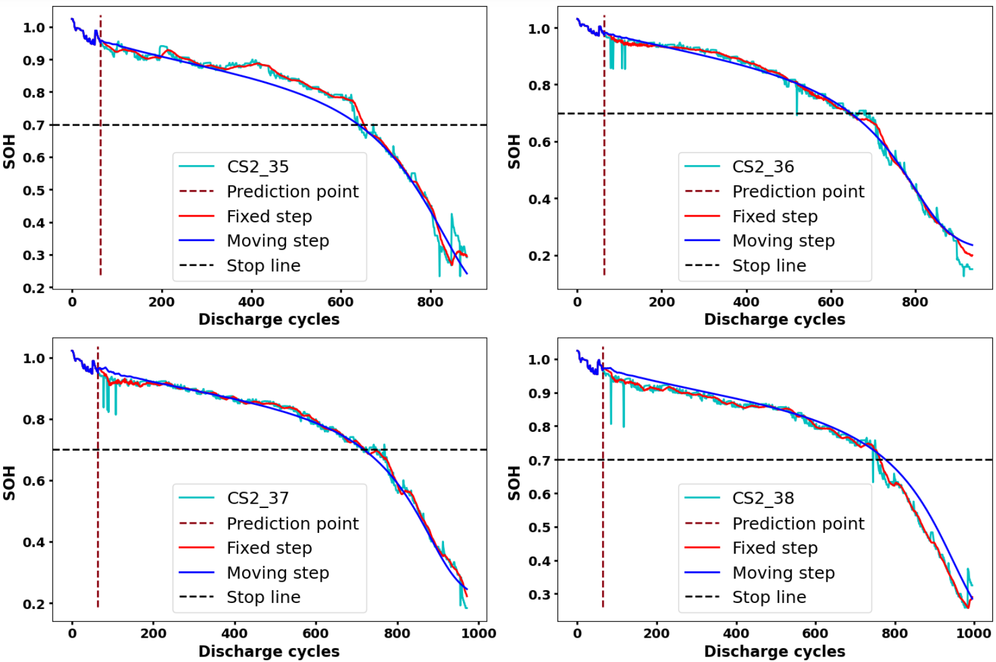

（a）NASA数据集。 （b）CALCE数据集。

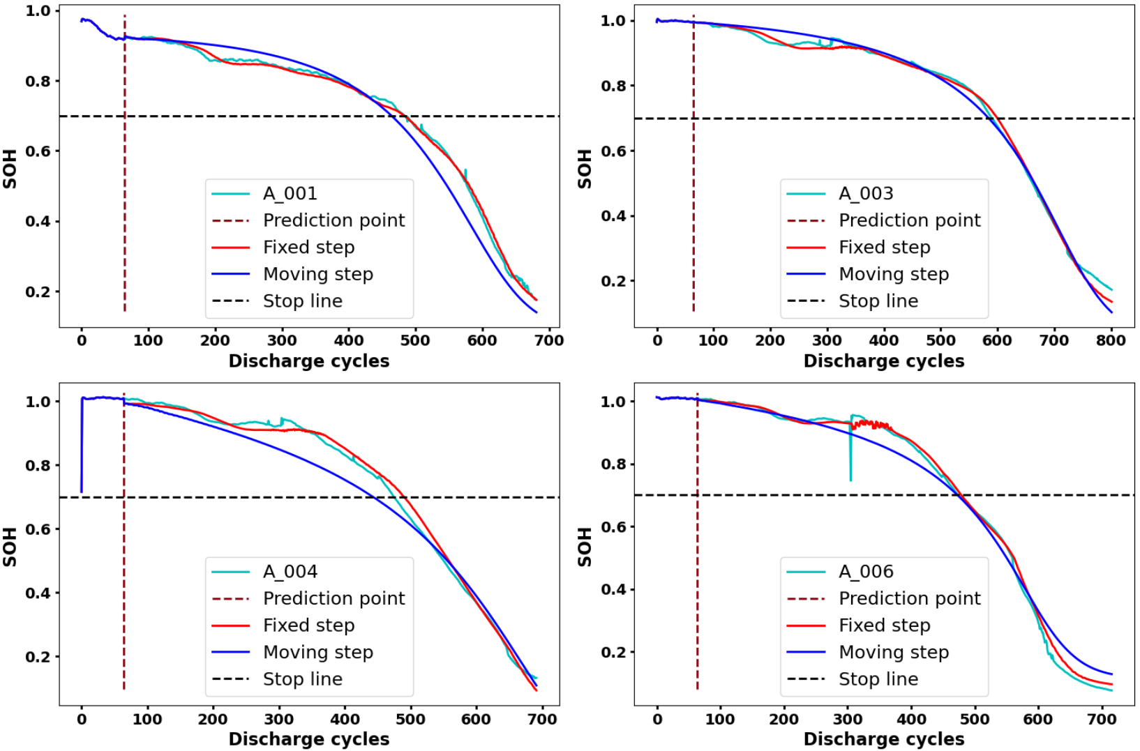

（c）WRBD数据集。

图7 不同数据集的SOH预测比较。

本文对提出的模型进行了单步预测（Fixed step）和多步预测（Moving step），具体结果如如图7所示。单步预测每次仅预测一个时间步长，并使用实际观测值作为下一次输入；多步预测则一次性预测多个时间步长，并用预测值作为后续输入。在评估NASA、CALCE和WRBD三个数据集上的电池SOH预测性能时，单步预测（Fixed Step）在各个数据集中均显示出卓越的准确性和精确性。该预测模式能够紧密跟随实际的电池放电曲线，展现了其高效的反应能力。这种精确度使得单步预测特别适合于需要即时反馈和高准确度的实时监测和预测应用。

The proposed model was evaluated using single-step prediction (Fixed Step) and multi-step prediction (Moving Step), with the results shown in **Figure 7**. In single-step prediction, the model predicts one time step at a time, using actual observed values as input for subsequent predictions. In contrast, multi-step prediction predicts multiple time steps at once, using the predicted values as input for subsequent steps. When evaluating SOH prediction performance on the NASA, CALCE, and WRBD datasets, single-step prediction demonstrated exceptional accuracy and precision across all datasets. This prediction mode closely followed the actual battery discharge curves, showcasing its high responsiveness. Such accuracy makes single-step prediction particularly suitable for real-time monitoring and forecasting applications that require immediate feedback and high precision.

多步预测（Moving Step）则在模拟电池SOH的长期衰减趋势方面表现良好，虽然在电池生命周期的末期，预测精度通常会有所下降。这种预测模式的平滑性非常适用于需要进行长期趋势分析的场景，如维护调度和寿命预测，但需要注意的是，其性能会受到累积误差的显著影响，尤其是在电池快速衰退阶段。

Multi-step prediction performed well in simulating the long-term degradation trends of battery SOH, though prediction accuracy typically decreased during the latter stages of the battery lifecycle. The smoothness of this prediction mode is highly beneficial for scenarios requiring long-term trend analysis, such as maintenance scheduling and lifespan forecasting. However, its performance is significantly affected by cumulative errors, especially during phases of rapid battery degradation.

就数据集的具体特性而言，NASA数据集中的电池展示了相对稳定的衰减过程，预测结果显示出良好的贴合度和低误差率，体现了模型的可靠性。CALCE数据集的电池在控制严格的实验条件下展现出不同的衰减模式，模型在这些条件下展现了出色的适应性和准确性，尤其是在处理电池容量的快速变化方面表现突出。而WRBD数据集提供了更为复杂的现实世界电池使用场景，电池的衰减行为表现得更为多变和不规则。尽管面临更大的挑战，模型仍能够较好地捕捉到长期趋势，展现了其广泛的应用潜力和良好的适应性。

Regarding the characteristics of the datasets, the NASA dataset exhibited relatively stable degradation processes, with prediction results showing good alignment and low error rates, highlighting the reliability of the model. The CALCE dataset, obtained under strictly controlled experimental conditions, revealed varying degradation patterns, and the model demonstrated excellent adaptability and accuracy under these conditions, particularly in handling rapid changes in battery capacity. The WRBD dataset, which provided more complex real-world battery usage scenarios, featured more variable and irregular degradation behavior. Despite these challenges, the model was still able to capture long-term trends effectively, demonstrating its broad applicability and strong adaptability.

**3.5消融实验**

**3.5 Ablation Study**

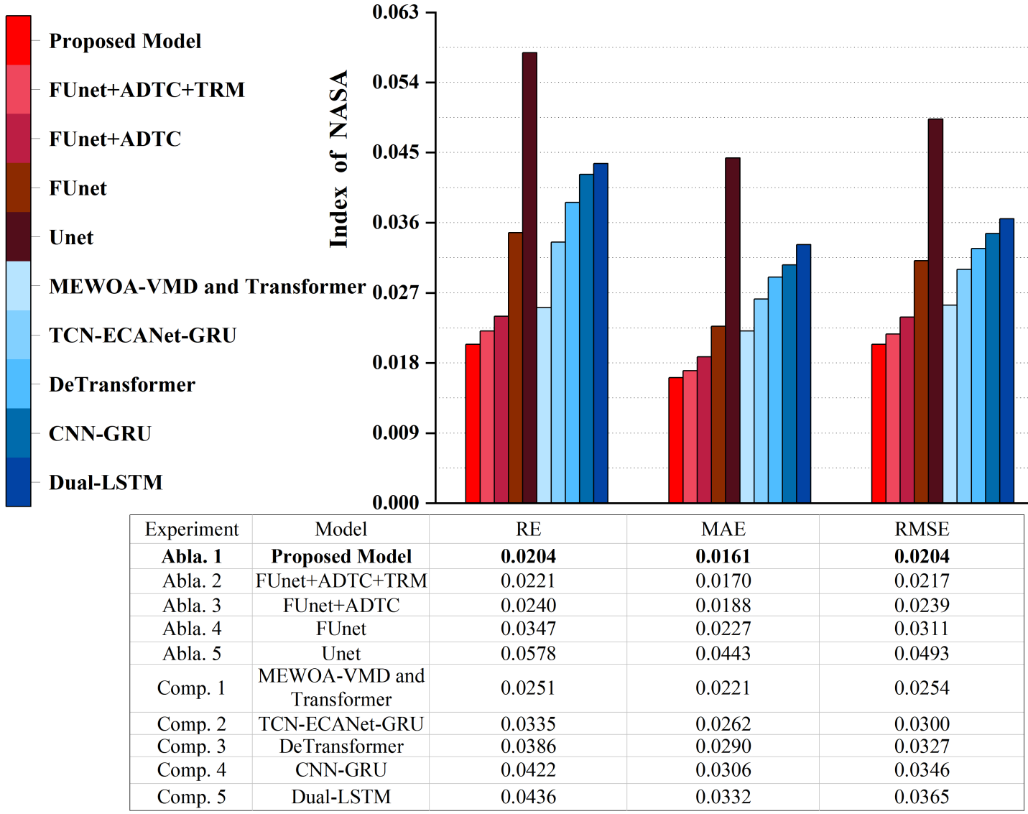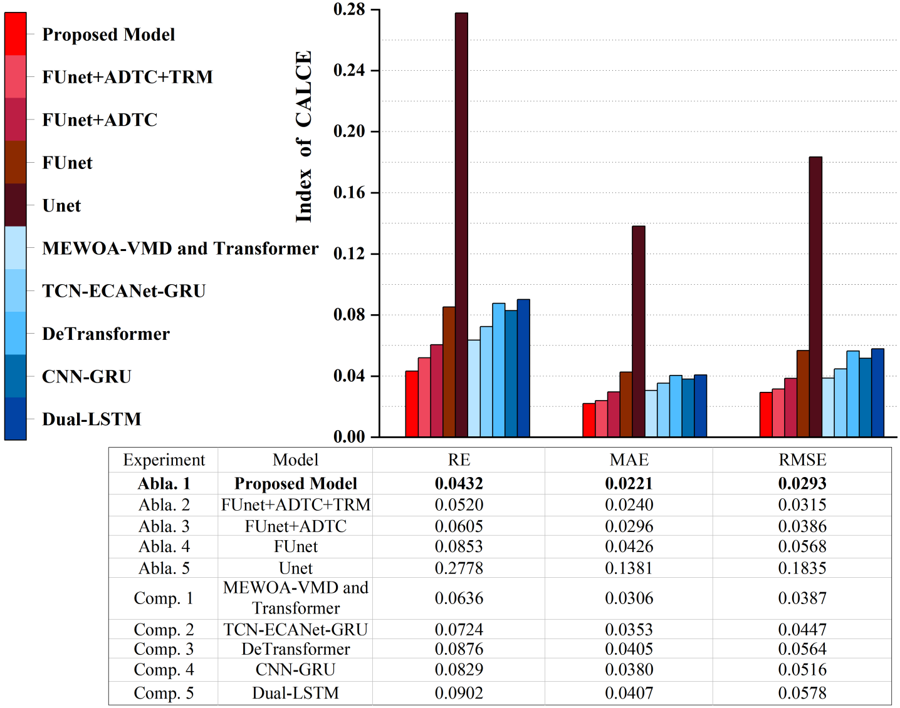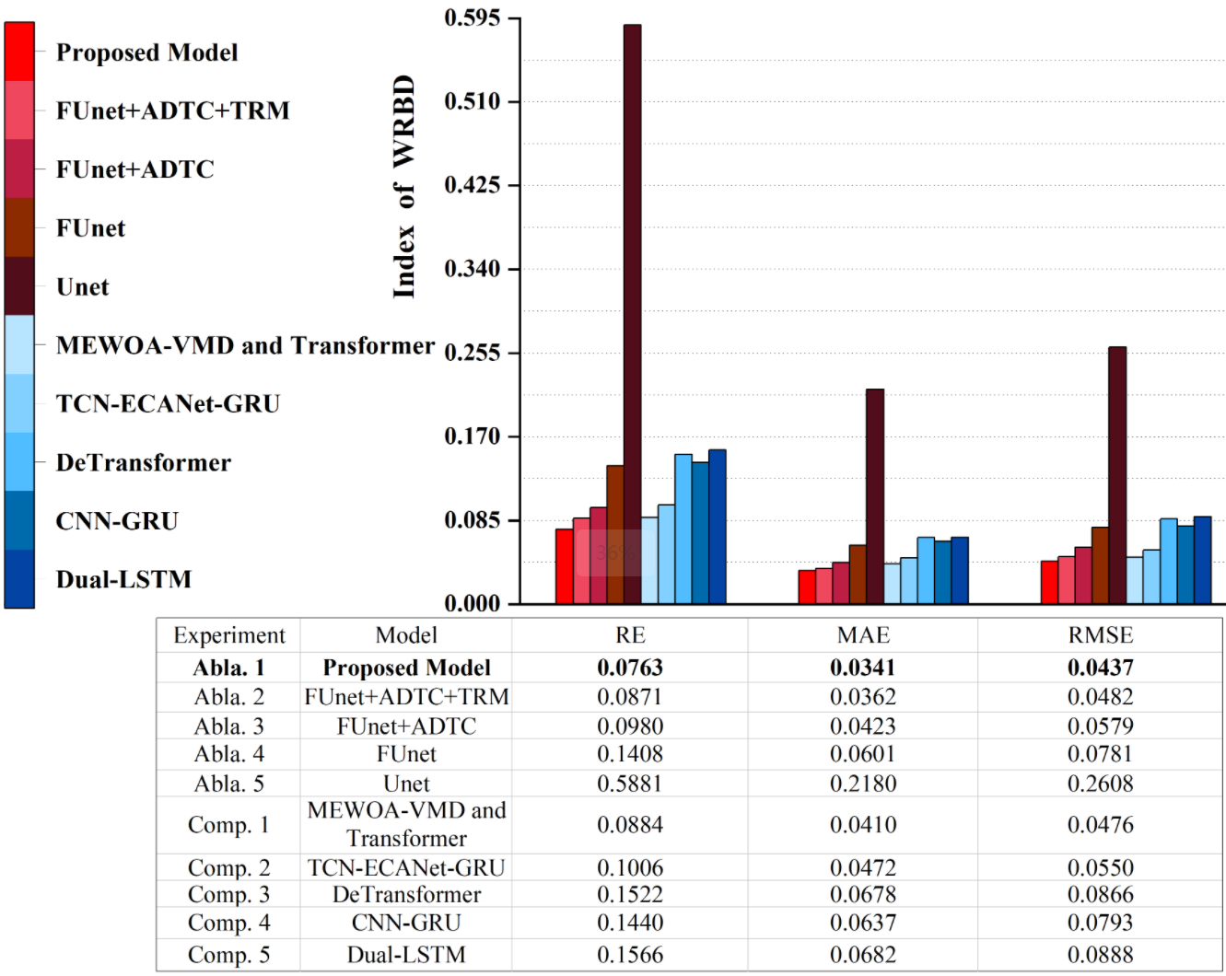

（a）NASA数据集。 （b）CALCE数据集。 （c）WRBD数据集。

图8 不同数据集的评估指标比较。

本文通过逐步增加各个模块对电池状态健康（SOH）预测模型进行了详细的消融实验，具体如图8所示。基础的U-Net模型作为性能基线，展示了在捕捉电池基本特征方面的基础能力，但面对复杂的电池衰减模式时表现有限。随后引入的FUnet，通过整合特征金字塔网络（FPN），显著增强了对多尺度信息的处理能力，优化了对电池容量变化各阶段的捕捉。结合自适应膨胀时间卷积（ADTC）的FUnet进一步强化了时间序列数据的处理能力，特别是在识别电池性能中的长期依赖关系上。通过加入Transformer模块，FUnet+ADTC配置得以精准捕捉全局依赖关系，从而提升了预测的准确性和稳定性。最终，加入Kolmogorov-Arnold网络（KAN）的完整模型在处理高维特征和复杂函数映射方面显示出卓越性能，显著降低了各项误差指标，如相对误差（RE）、平均绝对误差（MAE）和均方根误差（RMSE），彰显了该复合模型在挑战性电池衰减数据处理任务中的优越性。整体而言，每个新增模块的加入不仅证实了其有效性，还增强了模型在电池健康监测中的实用性和可靠性。

A detailed ablation study was conducted to evaluate the contributions of each module in the proposed SOH prediction model, as shown in **Figure 8**. The baseline U-Net model demonstrated its fundamental ability to capture basic battery characteristics, but it showed limitations when handling complex battery degradation patterns. The integration of the FUnet module, with its Feature Pyramid Network (FPN), significantly improved the processing of multi-scale information and optimized the model’s ability to capture battery capacity changes across various stages. When combined with the Adaptive Dilated Temporal Convolution (ADTC), the FUnet further enhanced its ability to handle time-series data, particularly in recognizing long-term dependencies in battery performance. Adding the Transformer module to the FUnet+ADTC configuration enabled the model to precisely capture global dependencies, which improved prediction accuracy and stability. Finally, the inclusion of the Kolmogorov-Arnold Network (KAN) in the full model demonstrated outstanding performance in managing high-dimensional features and complex functional mappings. This addition significantly reduced key error metrics, including Relative Error (RE), Mean Absolute Error (MAE), and Root Mean Square Error (RMSE), underscoring the superior capability of the composite model for handling challenging battery degradation data. Overall, the incremental inclusion of each module not only validated its effectiveness but also enhanced the model’s practicality and reliability in battery health monitoring applications.

**3.6对比实验**

**3.6 Comparative Experiments**

本文进行了一系列对比实验，旨在评估新提出的完整模型（FUnet+ADTC+TRM+KAN）与包括Dual-LSTM、DeTransformer、CNN-GRU、TCN-ECANet-GRU及MEWOA-VMD and Transformer在内的其他先进模型在锂离子电池SOH预测上的性能。简单组合模型虽在特定条件下可提供可靠预测，但在处理高维复杂数据时常显不足；而复杂组合模型则凭借其先进的数据处理能力，在预测精度和稳定性方面通常表现更佳，尤其擅长应对类似WRBD数据集这种噪声和变化都很大的复杂数据环境。本文提出的FUnet+ADTC+TRM+KAN模型在所有对比实验中表现最为出色，特别是在高难度数据集上，通过整合特征金字塔网络、自适应膨胀时间卷积、Transformer及Kolmogorov-Arnold网络，该模型显著提升了特征提取效率和准确性，并优化了长期依赖关系的捕捉和处理。实验结果显示，该模型在RE、MAE、RMSE等关键性能指标上均优于其他模型，尤其在处理包含复杂衰退模式和噪声数据的电池数据集时表现尤为突出。这一系列对比实验不仅验证了新模型的设计正确性，也展示了其在实际应用中的潜力和价值，为未来电池健康管理系统的技术支持提供了坚实的基础。

A series of comparative experiments were conducted to evaluate the performance of the proposed complete model (FUnet+ADTC+TRM+KAN) against other state-of-the-art models, including Dual-LSTM, DeTransformer, CNN-GRU, TCN-ECANet-GRU, and MEWOA-VMD and Transformer, in lithium-ion battery SOH prediction. While simpler composite models provided reliable predictions under specific conditions, they often showed limitations when dealing with high-dimensional and complex datasets. In contrast, more sophisticated composite models excelled in prediction accuracy and stability due to their advanced data processing capabilities, particularly in challenging environments like the WRBD dataset, which features substantial noise and variability. The proposed FUnet+ADTC+TRM+KAN model demonstrated the best overall performance across all comparative experiments. By integrating the Feature Pyramid Network, Adaptive Dilated Temporal Convolution, Transformer, and Kolmogorov-Arnold Network, the model significantly improved feature extraction efficiency and accuracy while optimizing the capture and processing of long-term dependencies. Experimental results revealed that the proposed model consistently outperformed its competitors in key performance metrics such as Relative Error (RE), Mean Absolute Error (MAE), and Root Mean Square Error (RMSE). Its superior performance was particularly evident in datasets characterized by complex degradation patterns and noisy data. These comparative experiments not only validated the design and effectiveness of the new model but also highlighted its potential and value in real-world applications. The results provide a solid foundation for advancing battery health management systems and demonstrate the model's capability to address the challenges of future energy storage technologies.

**3.7权值调试实验**

**3.7 Weight Adjustment Experiments**

在权值调试实验中，本文将ADTC和Transformer（TRM）的权值之和设为1，并分别测试了ADTC和Transformer权值在“0.1+0.9”、“0.2+0.8”……“0.9+0.1”的九种组合，旨在探讨局部特征与全局特征在不同权值分布下的贡献平衡。此外，为了验证这种权值调试的合理性，实验还将这些组合的结果与直接简单相加的权值分布（1:1比值，即未加权处理）进行了对比分析。通过这种设置，研究不同数据集的特性对权值分布优化的影响，为模型设计提供数据支持。具体实验结果如表3和图9所示。

In the weight adjustment experiments, the sum of the weights assigned to the ADTC and Transformer (TRM) modules was fixed at 1. Nine different combinations of ADTC and Transformer weights were tested, including "0.1+0.9," "0.2+0.8," ... "0.9+0.1," to explore the balance of contributions between local and global features under varying weight distributions. Additionally, to validate the rationale of this weight adjustment, the results of these combinations were compared against a simple unweighted (1:1) distribution, where the contributions of ADTC and Transformer were directly added without any weighting. This experiment was designed to study how different datasets influence the optimization of weight distributions, providing data-driven insights for model design. The results demonstrated that specific weight distributions performed better for certain datasets, indicating that the balance between local feature extraction (ADTC) and global dependency modeling (Transformer) plays a critical role in performance optimization. Detailed results of the experiment are presented in Table 3 and illustrated in Figure 9, which highlight the influence of different weight settings on prediction performance across datasets. These findings underline the importance of adaptively adjusting weights to align with the characteristics of the input data.

表3ADTC与Transformer权值分布调试实验的结果比较。

|  |  |  |  |  |  |  |
| --- | --- | --- | --- | --- | --- | --- |
| **Model** | **Dataset** | **Weight Distribution** | | **Evaluation Metric** | | |
| **ADTC** | **TRM** | **RE** | **MAE** | **RMSE** |
| **Proposed**  **Model** | **NASA** | **1** | **1** | **0.0204** | **0.0161** | **0.0204** |
| **0.1** | **0.9** | **0.0245** | **0.0184** | **0.0212** |
| **0.2** | **0.8** | **0.0204** | **0.0158** | **0.0203** |
| **0.3** | **0.7** | **0.0208** | **0.0161** | **0.0201** |
| **0.4** | **0.6** | **0.0202** | **0.0157** | **0.0193** |
| **0.5** | **0.5** | **0.0203** | **0.0157** | **0.0192** |
| **0.6** | **0.4** | **0.0194** | **0.0150** | **0.0181** |
| **0.7** | **0.3** | **0.0213** | **0.0164** | **0.0195** |
| **0.8** | **0.2** | **0.0195** | **0.0150** | **0.0186** |
| **0.9** | **0.1** | **0.0237** | **0.0182** | **0.0212** |
| **CALCE** | **1** | **1** | **0.0432** | **0.0221** | **0.0293** |
| **0.1** | **0.9** | **0.1390** | **0.0692** | **0.0916** |
| **0.2** | **0.8** | **0.0860** | **0.0456** | **0.0543** |
| **0.3** | **0.7** | **0.0902** | **0.0412** | **0.0666** |
| **0.4** | **0.6** | **0.1066** | **0.0585** | **0.0723** |
| **0.5** | **0.5** | **0.0621** | **0.0355** | **0.0456** |
| **0.6** | **0.4** | **0.0469** | **0.0255** | **0.0326** |
| **0.7** | **0.3** | **0.0386** | **0.0205** | **0.0279** |
| **0.8** | **0.2** | **0.0918** | **0.0692** | **0.0707** |
| **0.9** | **0.1** | **0.0557** | **0.0315** | **0.0392** |
| **WRBD** | **1** | **1** | **0.0763** | **0.0341** | **0.0437** |
| **0.1** | **0.9** | **0.1428** | **0.0558** | **0.0770** |
| **0.2** | **0.8** | **0.1073** | **0.0468** | **0.0611** |
| **0.3** | **0.7** | **0.1148** | **0.0518** | **0.0617** |
| **0.4** | **0.6** | **0.1299** | **0.0512** | **0.0671** |
| **0.5** | **0.5** | **0.0785** | **0.0320** | **0.0434** |
| **0.6** | **0.4** | **0.0535** | **0.0267** | **0.0343** |
| **0.7** | **0.3** | **0.0680** | **0.0308** | **0.0387** |
| **0.8** | **0.2** | **0.0541** | **0.0245** | **0.0310** |
| **0.9** | **0.1** | **0.1066** | **0.0358** | **0.0498** |

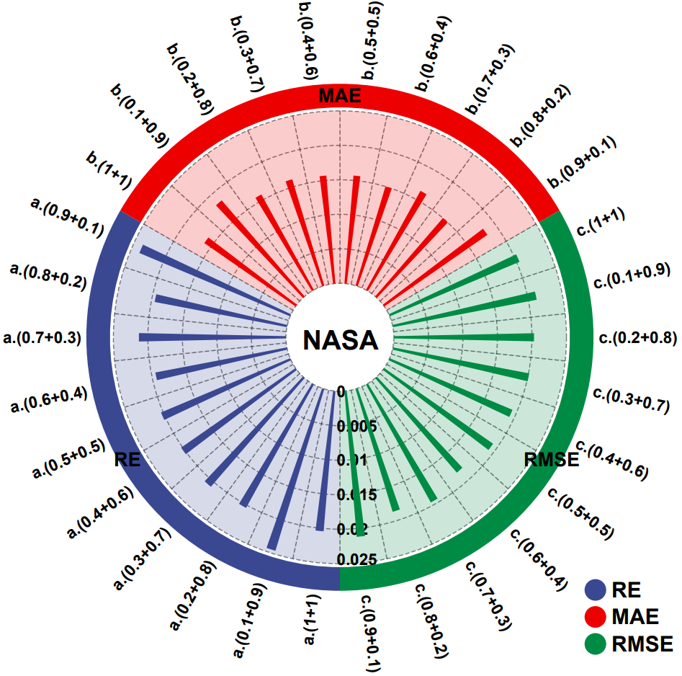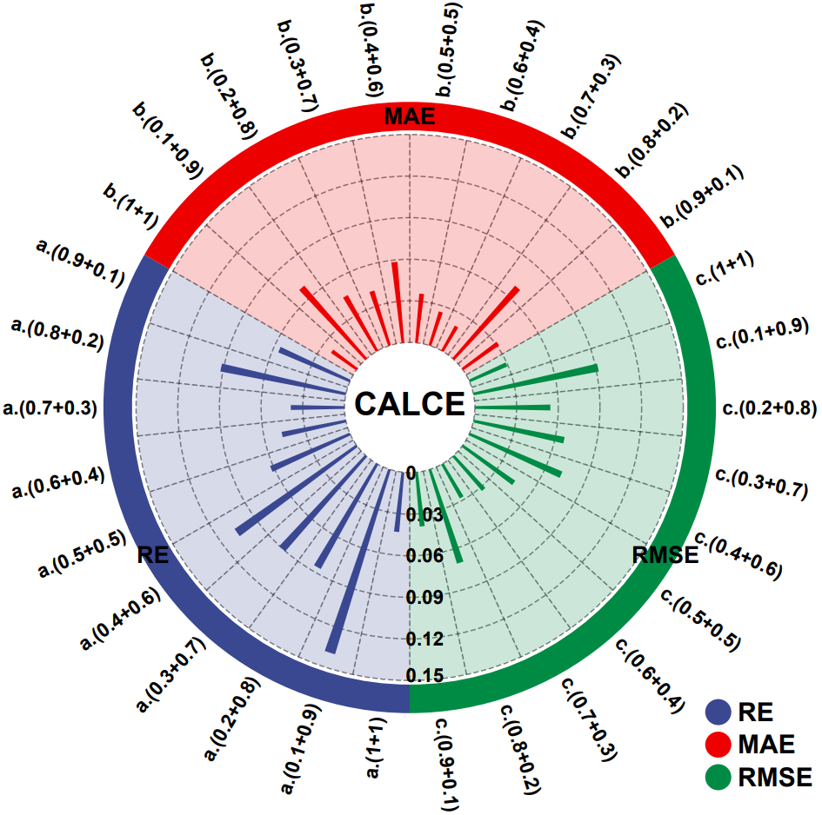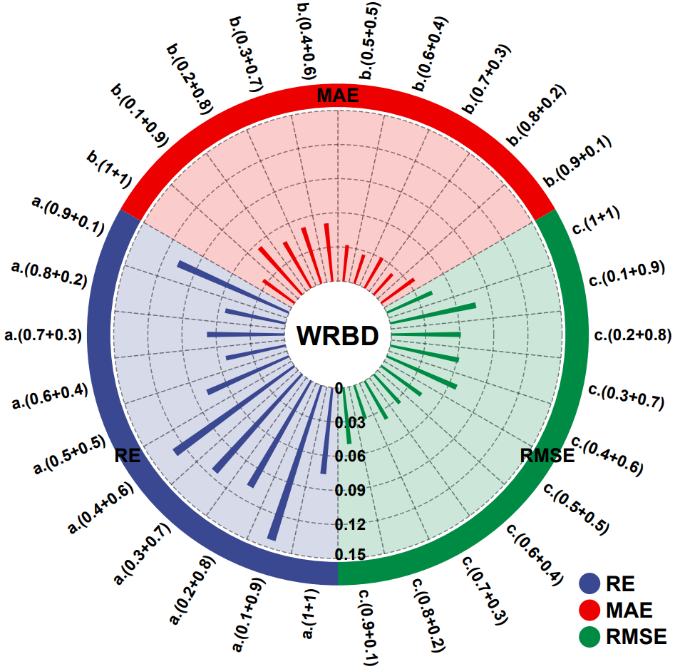

（a）NASA数据集。 （b）CALCE数据集。 （c）WRBD数据集。

图9 不同数据集的权值分布调试实验的结果比较。

权值调试实验的结果表明，不同数据集特性对模型中ADTC与Transformer权值的分布和性能影响存在显著差异。当ADTC与Transformer的权值相等时，模型表现较为理想，但未达到最佳。对于NASA数据集，该数据集以短序列为主（长度约132~168），局部特征主导性能，最佳权值分布为ADTC占比0.6，而全局特征的占比较低不会显著影响表现。对于CALCE数据集，该数据集为长序列（长度约881~995），局部与全局特征的平衡尤为重要，最佳权值分布为ADTC占比0.7。对于WRBD数据集，该数据集的序列较长且复杂性高（长度约681~801），局部特征的贡献更为重要，最佳权值分布为ADTC占比0.8。

The results of the weight adjustment experiments revealed significant differences in the influence of ADTC and Transformer weight distributions on model performance across datasets with varying characteristics. When the weights of ADTC and Transformer were equal, the model exhibited relatively good performance but did not achieve optimal results. For the **NASA dataset**, characterized by shorter sequences (approximately 132–168 in length), **local features dominated the performance**, and the best weight distribution was an ADTC ratio of **0.6**, indicating that a lower proportion of global features did not significantly affect performance. For the **CALCE dataset**, which comprises longer sequences (approximately 881–995 in length), a **balance between local and global features** was crucial. The optimal weight distribution was an ADTC ratio of **0.7**, showing that while local features contributed slightly more, global features remained essential for accurate prediction. For the **WRBD dataset**, known for its longer and highly complex sequences (approximately 681–801 in length), **local features played a more critical role**, and the best weight distribution was an ADTC ratio of **0.8**, emphasizing the need for the model to prioritize detailed local feature extraction. These findings underline the importance of dynamically tuning the weights of local (ADTC) and global (Transformer) components based on the dataset’s characteristics, enabling the model to adapt effectively to diverse data scenarios.

从权值分布对性能起伏的影响来看，NASA数据集表现出较小的性能波动。这是由于其短序列特性和单一的数据模式决定的，局部特征占据主导地位，ADTC即可满足特征提取需求，权值调整对性能的影响有限。而对于CALCE和WRBD数据集，权值分布变化对性能的影响较为显著。CALCE和WRBD数据集的长序列特性表明局部与全局特征的重要性需要精确平衡，权值失衡会导致性能显著下降。此外，WRBD数据集因其更高的复杂性，对局部特征的依赖更强，权值分布不合理时表现出更大的性能波动。

From the perspective of the impact of weight distribution on performance fluctuations, the **NASA dataset** exhibited relatively minor performance variations. This is attributed to its **short sequence characteristics** and **uniform data patterns**, where **local features dominate**. The ADTC module alone is sufficient to meet the feature extraction requirements, resulting in limited influence from weight adjustments on model performance. In contrast, the **CALCE** and **WRBD datasets** showed more pronounced impacts from weight distribution changes. The **long sequence characteristics** of these datasets indicate that **both local and global features must be precisely balanced** to achieve optimal performance. An imbalance in weight distribution can lead to significant performance degradation. Furthermore, the **WRBD dataset**, due to its higher complexity, exhibited a **stronger reliance on local features**. When the weight distribution was unreasonable, the model demonstrated **greater performance fluctuations**, emphasizing the importance of fine-tuning the balance between ADTC and Transformer weights to handle complex, diverse data scenarios effectively.

数据集特性进一步揭示了短序列和长序列在权值分布上的差异。短序列中，局部特征占主导，权值变化的影响较小；而长序列则需要更好地平衡局部与全局特征，权值分布变化会引起显著的性能波动。同时，数据复杂性越高（如WRBD数据集），对局部特征的依赖增强，权值分布不合理会加剧性能的不稳定性。

The dataset characteristics further highlight the differences in weight distribution between short and long sequences. In **short sequences**, local features dominate, making the model less sensitive to weight distribution changes. In contrast, **long sequences** require a better balance between local and global features, where variations in weight distribution can lead to significant performance fluctuations. Additionally, the higher the **data complexity** (e.g., in the WRBD dataset), the stronger the reliance on local features, and **improper weight distribution** can exacerbate performance instability.

实验表明，ADTC在局部特征提取方面表现优异，凭借多分支结构、自适应膨胀卷积和非线性激活机制，能够精准建模短时间依赖特征，而其全局特征的捕获则通过多尺度感受野间接实现。相比之下，Transformer凭借自注意力机制直接捕获全局依赖，擅长建模长期特征趋势，但在局部特征敏感性上略显不足。因此，优化权值分布需要结合序列长度和数据复杂度进行动态调整，例如NASA的最佳分布为0.6:0.4，CALCE为0.7:0.3，WRBD为0.8:0.2。

Experimental results demonstrate that the **ADTC** module excels in local feature extraction. With its multi-branch structure, adaptive dilated convolution, and nonlinear activation mechanisms, ADTC effectively models short-term dependency features, while global feature capturing is indirectly achieved through multi-scale receptive fields. In contrast, the **Transformer** module leverages its self-attention mechanism to directly capture global dependencies, making it adept at modeling long-term feature trends, though it exhibits relatively lower sensitivity to local features. Thus, optimizing the weight distribution requires dynamic adjustments based on sequence length and data complexity. For example, the optimal weight distribution is **0.6:0.4** for the NASA dataset, **0.7:0.3** for the CALCE dataset, and **0.8:0.2** for the WRBD dataset.

综合来看，NASA数据集的局部特征主导使得权值分布变化对性能影响较小，而CALCE和WRBD数据集因序列较长且复杂度更高，表现出更大的权值分布敏感性。未来研究将致力于探索动态权值分配和模块协同优化策略，以进一步提升模型的鲁棒性与适应性，为更广泛的数据场景提供可靠的解决方案。

In summary, the dominance of local features in the NASA dataset results in relatively minor performance impacts from changes in weight distribution. In contrast, the CALCE and WRBD datasets, with their longer sequences and higher complexity, exhibit greater sensitivity to weight distribution. Future research will focus on exploring dynamic weight allocation and module collaboration optimization strategies to further enhance the robustness and adaptability of the model, providing reliable solutions for a broader range of data scenarios.

**4 总结**

**4 Conclusion**

本文提出了一种基于深度学习的多阶段多尺度特征提取与融合的锂离子电池健康状态预测模型，整合了自适应膨胀时间卷积（ADTC）、Transformer编码器、增强型FUnet模块以及Kolmogorov-Arnold网络（KAN）。通过多阶段多尺度的特征提取与融合，该模型在NASA、CALCE和WRBD等数据集上的预测性能显著优于传统模型。模型实现了局部与全局特征的协同提取，通过ADTC和Transformer模块的并行加权机制，精准捕获短期依赖的局部特征与长期依赖的全局特征，并通过权值优化动态平衡各特征的贡献。此外，FUnet模块结合特征金字塔结构与全局平均池化技术，全面提升了多尺度特征的融合效率，使模型能够更好地适应复杂时间序列数据的多样性。在最终预测方面，KAN模块以非线性激活函数和B样条插值为核心，对高维特征间的复杂关系进行了有效处理，显著提高了预测精度与鲁棒性。实验结果表明，该模型能够准确捕捉电池健康状态的关键变化特征，适应多样化的数据模式，同时在预测精度和稳定性上均表现卓越。本文的研究为锂离子电池的高效管理和安全运行提供了有效的技术方法，同时也为时间序列预测领域的算法设计提出了具有实用价值的改进思路，为相关领域的进一步研究和应用提供了帮助。

This paper proposes a deep learning-based multi-stage, multi-scale feature extraction and fusion model for lithium-ion battery state-of-health (SOH) prediction. The model integrates Adaptive Dilated Temporal Convolution (ADTC), Transformer Encoder, enhanced FUnet module, and Kolmogorov-Arnold Network (KAN). By leveraging multi-stage and multi-scale feature extraction and fusion, the proposed model demonstrates significantly improved predictive performance compared to traditional models on NASA, CALCE, and WRBD datasets. The model achieves collaborative extraction of local and global features through the parallel weighting mechanism of ADTC and Transformer modules, enabling precise capture of short-term local dependencies and long-term global trends while dynamically balancing the contributions of each feature via weight optimization. Additionally, the FUnet module incorporates a Feature Pyramid Network (FPN) structure and global average pooling techniques, enhancing the efficiency of multi-scale feature fusion and improving adaptability to diverse, complex time-series data. In the final prediction phase, the KAN module, leveraging nonlinear activation functions and B-spline interpolation, effectively processes the complex relationships between high-dimensional features, significantly improving prediction accuracy and robustness. Experimental results demonstrate that the proposed model accurately captures critical changes in battery health, adapts to diverse data patterns, and achieves superior performance in prediction accuracy and stability. This study provides an effective technical approach for efficient lithium-ion battery management and safe operation. Moreover, it introduces valuable improvements in algorithm design for time-series prediction, offering practical insights and laying the foundation for further research and applications in related fields.

未来的研究将进一步聚焦于模型结构的优化，包括探索更为灵活的动态权值分配机制和模块间的协同优化策略，以确保模型在不同工况和复杂序列数据场景下保持稳定表现。同时，将在更多实际应用场景中对模型进行深入测试与验证，结合前沿深度学习技术，不断提升其在健康状态预测中的适应性和可靠性。

Future research will focus on optimizing the model structure, including exploring more flexible dynamic weight allocation mechanisms and collaborative optimization strategies among modules to ensure stable performance under diverse operating conditions and complex sequence data scenarios. Additionally, the model will undergo extensive testing and validation in more real-world application scenarios. By integrating cutting-edge deep learning techniques, efforts will aim to further enhance the model's adaptability and reliability in state-of-health prediction tasks.

**CRediT authorship contribution statement**

**Chuang Chen:** Writing – original draft, Investigation, Methodology, Funding acquisition. **Yuheng Wu:** Writing – original draft, Methodology, Software, Validation. **Jiantao Shi:** Writing – review & editing, Supervision, Resources, Project administration, Funding acquisition. **Dongdong Yue:** Conceptualization, Writing – review & editing. **Dongzhen Lyu:** Resources, Writing – review & editing. **Hongtian Chen:** Funding acquisition, Writing – review & editing.

**Declaration of competing interest**

The authors declare that they have no known competing financial interests or personal relationships that could have appeared to influence the work reported in this paper.

**Acknowledgments**

This work was supported in part by the National Natural Science Foundation of China under Grant 62303217, Grant 62373184, and Grant 62303308; in part by China Postdoctoral Science Foundation under Grant 2024M751977; in part by the Natural Science Foundation of the Jiangsu Higher Education Institutions of China under Grant 23KJB510006; and in part by Shanghai Pujiang Program under Grant 23PJ1404700.

参考文献

References

[1] M. Zhang, Y. Liu, D. Li, X. Cui, L. Wang, L. Li, and K. Wang, “Electrochemical impedance spectroscopy: A new chapter in the fast and accurate estimation of the state of health for lithium-ion batteries,” *Energies*, vol. 16, no. 1599, 2023.

[2] M. H. Lipu, M. A. Hannan, A. Hussain, S. Ansari, S. A. Rahman, M. H. Saad, and K. M. Muttaqi, “Real-time state of charge estimation of lithium-ion batteries using optimized random forest regression algorithm,” IEEE Trans. Veh. Technol., vol. 8, no. 1, pp. 639–648, Jan. 2023.

[3] P. Wen, Z. -S. Ye, Y. Li, S. Chen, P. Xie, and S. Zhao, “Physics-informed neural networks for prognostics and health management of lithium-ion batteries,” IEEE Trans. Veh. Technol., vol. 9, no. 1, pp. 2276–2289, Jan. 2024.

[4] S. Vignesh, H. S. Che, J. Selvaraj, et al., “State of Health (SoH) estimation methods for second life lithium-ion battery—Review and challenges,” *Applied Energy*, vol. 369, pp. 123542, 2024.

[5] G. Chen, Z. Liu, H. Su, et al., “Electrochemical-distributed thermal coupled model-based state of charge estimation for cylindrical lithium-ion batteries,” *Control Engineering Practice*, vol. 109, pp. 104734, 2021.

[6] D. Lyu, G. Niu, B. Zhang, et al., “Lebesgue-time–space-model-based diagnosis and prognosis for multiple mode systems,” *IEEE Transactions on Industrial Electronics*, vol. 68, no. 2, pp. 1591–1603, 2020.

[7] P. Singh, C. Chen, C. M. Tan, et al., “Semi-empirical capacity fading model for SoH estimation of Li-ion batteries,” *Applied Sciences*, vol. 9, no. 15, pp. 3012, 2019.

[8] L. Cai, M. Holdstock, M. V. Morganti, et al., “A semi-empirical state of health estimation method for batteries of electric vehicles operating in varying real-world conditions,” *IEEE Access*, 2024, in press.

[9] C. Lin, A. Tang, and W. Wang, “A review of SOH estimation methods in Lithium-ion batteries for electric vehicle applications,” *Energy Procedia*, vol. 75, pp. 1920–1925, 2015.

[10] O. Demirci, S. Taskin, E. Schaltz, et al., “Review of battery state estimation methods for electric vehicles-Part II: SOH estimation,” *Journal of Energy Storage*, vol. 96, pp. 112703, 2024.

[11] H. Chen, B. Jiang, and S. X. Ding, “A broad learning aided data-driven framework of fast fault diagnosis for high-speed trains,” *IEEE Intelligent Transportation Systems Magazine*, vol. 13, no. 3, pp. 83–88, 2020.

[12] H. Chen, Z. Chai, O. Dogru, et al., “Data-driven designs of fault detection systems via neural network-aided learning,” *IEEE Transactions on Neural Networks and Learning Systems*, vol. 33, no. 10, pp. 5694–5705, 2021.

[13] C. Chen, G. Tao, J. Shi, M. Shen, and Z.H. Zhu, “A Lithium-ion battery degradation prediction model with uncertainty quantiffcation for its predictive maintenance,” IEEE Trans. Ind. Electron., vol. 71, no. 4, pp. 3650–3659, Apri. 2024.

[14] J. Lu, R. Xiong, J. Tian, C. Wang, C.-W. Hsu, N.-T. Tsou, F. Sun, and J. Li, “Battery degradation prediction against uncertain future conditions with recurrent neural network enabled deep learning,” Energy Storage Mater., vol. 50, pp. 139–151, Sep. 2022.

[15] L. Zhang, B. Wang, X. Yuan, and P. Liang, “Remaining useful life prediction via improved CNN, GRU, and residual attention mechanism with soft thresholding,” IEEE Sensors J., vol. 22, no. 15, pp. 15178–15190, Aug. 2022.

[16] L. Ren, J. Dong, X. Wang, et al., “A data-driven auto-CNN-LSTM prediction model for lithium-ion battery remaining useful life,” IEEE Trans. Ind. Inform., vol. 17, no. 5, pp. 3478–3487, 2020.

[17] L. Ungurean, M. V. Micea, and G. Cârstoiu, “Online state of health prediction method for lithium-ion batteries, based on gated recurrent unit neural networks,” Int. J. Energy Res., vol. 44, no. 8, pp. 6767–6777, Jun. 2020.

[18] Y. Ma, C. Shan, J. Gao, and H. Chen, “A novel method for state of health estimation of lithium-ion batteries based on improved LSTM and health indicators extraction,” Energy, vol. 251, pp. 123973, Jul. 2022.

[19] Y. Li, L. Luo, C. Zhang, and H. Liu, “State of health assessment for lithium-ion batteries using incremental energy analysis and bidirectional long short-term memory,” World Electric Vehicle J., vol. 14, no. 7, pp. 188, Jul. 2023.

[20] C. J. Valant, J. D. Wheaton, M. G. Thurston, et al., “Evaluation of 1D CNN autoencoders for lithium-ion battery condition assessment using synthetic data,” Proc. Annu. Conf. PHM Soc., vol. 11, no. 1, pp. 1–11, 2019.

[21] F. Durmus and S. Karagol, “Lithium-Ion Battery Capacity Prediction with GA-Optimized CNN, RNN, and BP,” Applied Sciences, vol. 14, no. 13, pp. 5662, 2024.

[22] Q. Chen, Y. B. Liu, M. F. Ge, et al., “A novel Bayesian-optimization-based adversarial TCN for RUL prediction of bearings,” IEEE Sensors J., vol. 22, no. 21, pp. 20968–20977, 2022.

[23] Y. Liu, J. Li, G. Zhang, et al., “State of charge estimation of lithium-ion batteries based on temporal convolutional network and transfer learning,” IEEE Access, vol. 9, pp. 34177–34187, 2021.

[24] H. Shen, X. Zhou, Z. Wang, et al., “State of charge estimation for lithium-ion battery using Transformer with immersion and invariance adaptive observer,” J. Energy Storage, vol. 45, pp. 103768, 2022.

[25] Y. Han, C. Li, L. Zheng, et al., “Remaining useful life prediction of lithium-ion batteries by using a denoising transformer-based neural network,” Energies, vol. 16, no. 17, pp. 6328, 2023.

[26] J. Zhao and Z. Wang, “Specialized convolutional transformer networks for estimating battery health via transfer learning,” Energy Storage Mater., vol. 71, pp. 103668, 2024.

[27] X. Fan, X. Yang, and F. Hou, “Integrated mixed attention U-Net mechanisms with multi-stage division strategy customized for accurate estimation of lithium-ion battery state of health,” Electronics, vol. 13, no. 16, pp. 3244, 2024.

[28] L. Song, Q. Hu, W. Shu, et al., “An optimized visual measurement method for cell parallelism based on edge-aware dynamic re-weighted U-Net (EADRU-Net),” Signal, Image and Video Process., pp. 1–10, 2024.

[29] X. Bao, L. Chen, A. M. Lopes, et al., “Hybrid deep neural network with dimension attention for state-of-health estimation of lithium-ion batteries,” Energy, vol. 278, pp. 127734, 2023.

[30] F.-K. Wang, Z. E. Amogne, J.-H. Chou, and C. Tseng, “Online remaining useful life prediction of lithium-ion batteries using bidirectional long short-term memory with attention mechanism,” Energy, vol. 254, pp. 124344, Sep. 2022.

[31] Z. Liu, Y. Wang, S. Vaidya, et al., “Kan: Kolmogorov-Arnold networks,” *arXiv preprint*, arXiv:2404.19756, 2024.

[32] D. Lyu, B. Zhang, E. Zio, et al., “Battery cumulative lifetime prognostics to bridge laboratory and real-life scenarios,” Cell Reports Physical Science, vol. 5, no. 9, pp. –, 2024..

[33] Z. Shi and A. Chehade, “A dual-LSTM framework combining change point detection and remaining useful life prediction,” Reliab. Eng. Syst. Saf., vol. 205, Art no. 107257, 2021.

[34] S. Sun, J. Wang, Y. Xiao, J. Peng, and X. Zhou, “Few-shot RUL prediction for engines based on CNN-GRU model,” Sci. Rep., vol. 14, no. 1, Art no. 16041, 2024.

[35] D. Chen, W. Hong, and X. Zhou, “Transformer network for remaining useful life prediction of lithium-ion batteries,” IEEE Access, vol. 10, pp. 19621–19628, Feb. 2022.

[36] X. Xiang, X. Li, Y. Zhang, et al., “A short-term forecasting method for photovoltaic power generation based on the TCN-ECANet-GRU hybrid model,” Scientific Reports, vol. 14, no. 1, pp. 6744, 2024.

[37] Y. Chen, X. Huang, Y. He, et al., “Edge–cloud collaborative estimation lithium-ion battery SOH based on MEWOA-VMD and Transformer,” Journal of Energy Storage, vol. 99, pp. 113388, 2024.

（姓在前）

[1] Zhang, M., Liu, Y., Li, D., Cui, X., Wang, L., Li, L., & Wang, K. (2023). Electrochemical impedance spectroscopy: A new chapter in the fast and accurate estimation of the state of health for lithium-ion batteries. *Energies, 16*(1599).

[2] Lipu, M. H., Hannan, M. A., Hussain, A., Ansari, S., Rahman, S. A., Saad, M. H., & Muttaqi, K. M. (2023). Real-time state of charge estimation of lithium-ion batteries using optimized random forest regression algorithm. *IEEE Transactions on Vehicular Technology, 8*(1), 639–648.

[3] Wen, P., Ye, Z.-S., Li, Y., Chen, S., Xie, P., & Zhao, S. (2024). Physics-informed neural networks for prognostics and health management of lithium-ion batteries. *IEEE Transactions on Vehicular Technology, 9*(1), 2276–2289.

[4] Vignesh, S., Che, H. S., Selvaraj, J., et al. (2024). State of Health (SoH) estimation methods for second life lithium-ion battery—Review and challenges. *Applied Energy, 369*, Article 123542.

[5] Chen, G., Liu, Z., Su, H., et al. (2021). Electrochemical-distributed thermal coupled model-based state of charge estimation for cylindrical lithium-ion batteries. *Control Engineering Practice, 109*, Article 104734.

[6] Lyu, D., Niu, G., Zhang, B., et al. (2020). Lebesgue-time–space-model-based diagnosis and prognosis for multiple mode systems. *IEEE Transactions on Industrial Electronics, 68*(2), 1591–1603.

[7] Singh, P., Chen, C., Tan, C. M., et al. (2019). Semi-empirical capacity fading model for SoH estimation of Li-ion batteries. *Applied Sciences, 9*(15), 3012.

[8] Cai, L., Holdstock, M., Morganti, M. V., et al. (2024). A semi-empirical state of health estimation method for batteries of electric vehicles operating in varying real-world conditions. *IEEE Access*, in press.

[9] Lin, C., Tang, A., & Wang, W. (2015). A review of SOH estimation methods in Lithium-ion batteries for electric vehicle applications. *Energy Procedia, 75*, 1920–1925.

[10] Demirci, O., Taskin, S., Schaltz, E., et al. (2024). Review of battery state estimation methods for electric vehicles-Part II: SOH estimation. *Journal of Energy Storage, 96*, Article 112703.

[11] Chen, H., Jiang, B., & Ding, S. X. (2020). A broad learning aided data-driven framework of fast fault diagnosis for high-speed trains. *IEEE Intelligent Transportation Systems Magazine, 13*(3), 83–88.

[12] Chen, H., Chai, Z., Dogru, O., et al. (2021). Data-driven designs of fault detection systems via neural network-aided learning. *IEEE Transactions on Neural Networks and Learning Systems, 33*(10), 5694–5705.

[13] Chen, C., Tao, G., Shi, J., Shen, M., & Zhu, Z. H. (2024). A Lithium-ion battery degradation prediction model with uncertainty quantification for its predictive maintenance. *IEEE Transactions on Industrial Electronics, 71*(4), 3650–3659.

[14] Lu, J., Xiong, R., Tian, J., Wang, C., Hsu, C.-W., Tsou, N.-T., Sun, F., & Li, J. (2022). Battery degradation prediction against uncertain future conditions with recurrent neural network enabled deep learning. *Energy Storage Materials, 50*, 139–151.

[15] Zhang, L., Wang, B., Yuan, X., & Liang, P. (2022). Remaining useful life prediction via improved CNN, GRU, and residual attention mechanism with soft thresholding. *IEEE Sensors Journal, 22*(15), 15178–15190.

[16] Ren, L., Dong, J., Wang, X., et al. (2020). A data-driven auto-CNN-LSTM prediction model for lithium-ion battery remaining useful life. *IEEE Transactions on Industrial Informatics, 17*(5), 3478–3487.

[17] Ungurean, L., Micea, M. V., & Cârstoiu, G. (2020). Online state of health prediction method for lithium-ion batteries, based on gated recurrent unit neural networks. *International Journal of Energy Research, 44*(8), 6767–6777.

[18] Ma, Y., Shan, C., Gao, J., & Chen, H. (2022). A novel method for state of health estimation of lithium-ion batteries based on improved LSTM and health indicators extraction. *Energy, 251*, Article 123973.

[19] Li, Y., Luo, L., Zhang, C., & Liu, H. (2023). State of health assessment for lithium-ion batteries using incremental energy analysis and bidirectional long short-term memory. *World Electric Vehicle Journal, 14*(7), Article 188.

[20] Valant, C. J., Wheaton, J. D., Thurston, M. G., et al. (2019). Evaluation of 1D CNN autoencoders for lithium-ion battery condition assessment using synthetic data. *Proceedings of the Annual Conference of the PHM Society, 11*(1), 1–11.

[21] Durmus, F., & Karagol, S. (2024). Lithium-Ion Battery Capacity Prediction with GA-Optimized CNN, RNN, and BP. *Applied Sciences, 14*(13), Article 5662.

[22] Chen, Q., Liu, Y. B., Ge, M. F., et al. (2022). A novel Bayesian-optimization-based adversarial TCN for RUL prediction of bearings. *IEEE Sensors Journal, 22*(21), 20968–20977.

[23] Liu, Y., Li, J., Zhang, G., et al. (2021). State of charge estimation of lithium-ion batteries based on temporal convolutional network and transfer learning. *IEEE Access, 9*, 34177–34187.

[24] Shen, H., Zhou, X., Wang, Z., et al. (2022). State of charge estimation for lithium-ion battery using Transformer with immersion and invariance adaptive observer. *Journal of Energy Storage, 45*, Article 103768.

[25] Han, Y., Li, C., Zheng, L., et al. (2023). Remaining useful life prediction of lithium-ion batteries by using a denoising transformer-based neural network. *Energies, 16*(17), Article 6328.

[26] Zhao, J., & Wang, Z. (2024). Specialized convolutional transformer networks for estimating battery health via transfer learning. *Energy Storage Materials, 71*, Article 103668.

[27] Fan, X., Yang, X., & Hou, F. (2024). Integrated mixed attention U-Net mechanisms with multi-stage division strategy customized for accurate estimation of lithium-ion battery state of health. *Electronics, 13*(16), Article 3244.

[28] Song, L., Hu, Q., Shu, W., et al. (2024). An optimized visual measurement method for cell parallelism based on edge-aware dynamic re-weighted U-Net (EADRU-Net). *Signal, Image and Video Processing*, pp. 1–10.

[29] Bao, X., Chen, L., Lopes, A. M., et al. (2023). Hybrid deep neural network with dimension attention for state-of-health estimation of lithium-ion batteries. *Energy, 278*, Article 127734.

[30] Wang, F.-K., Amogne, Z. E., Chou, J.-H., & Tseng, C. (2022). Online remaining useful life prediction of lithium-ion batteries using bidirectional long short-term memory with attention mechanism. *Energy, 254*, Article 124344.

[31] Liu, Z., Wang, Y., Vaidya, S., et al. (2024). Kan: Kolmogorov-Arnold networks. *arXiv preprint*, arXiv:2404.19756.

[32] Lyu, D., Zhang, B., Zio, E., et al. (2024). Battery cumulative lifetime prognostics to bridge laboratory and real-life scenarios. *Cell Reports Physical Science, 5*(9), --.

[33] Shi, Z., & Chehade, A. (2021). A dual-LSTM framework combining change point detection and remaining useful life prediction. *Reliability Engineering & System Safety, 205*, Article 107257.

[34] Sun, S., Wang, J., Xiao, Y., Peng, J., & Zhou, X. (2024). Few-shot RUL prediction for engines based on CNN-GRU model. *Scientific Reports, 14*(1), Article 16041.

[35] Chen, D., Hong, W., & Zhou, X. (2022). Transformer network for remaining useful life prediction of lithium-ion batteries. *IEEE Access, 10*, 19621–19628.

[36] Xiang, X., Li, X., Zhang, Y., et al. (2024). A short-term forecasting method for photovoltaic power generation based on the TCN-ECANet-GRU hybrid model. *Scientific Reports, 14*(1), 6744.

[37] Chen, Y., Huang, X., He, Y., et al. (2024). Edge–cloud collaborative estimation lithium-ion battery SOH based on MEWOA-VMD and Transformer. *Journal of Energy Storage, 99*, Article 113388.

（姓在前+无序号）

• Zhang, M., Liu, Y., Li, D., Cui, X., Wang, L., Li, L., & Wang, K. (2023). Electrochemical impedance spectroscopy: A new chapter in the fast and accurate estimation of the state of health for lithium-ion batteries. *Energies, 16*(1599).

• Lipu, M. H., Hannan, M. A., Hussain, A., Ansari, S., Rahman, S. A., Saad, M. H., & Muttaqi, K. M. (2023). Real-time state of charge estimation of lithium-ion batteries using optimized random forest regression algorithm. *IEEE Transactions on Vehicular Technology, 8*(1), 639–648.

• Wen, P., Ye, Z.-S., Li, Y., Chen, S., Xie, P., & Zhao, S. (2024). Physics-informed neural networks for prognostics and health management of lithium-ion batteries. *IEEE Transactions on Vehicular Technology, 9*(1), 2276–2289.

• Vignesh, S., Che, H. S., Selvaraj, J., et al. (2024). State of Health (SoH) estimation methods for second life lithium-ion battery—Review and challenges. *Applied Energy, 369*, Article 123542.

• Chen, G., Liu, Z., Su, H., et al. (2021). Electrochemical-distributed thermal coupled model-based state of charge estimation for cylindrical lithium-ion batteries. *Control Engineering Practice, 109*, Article 104734.

• Lyu, D., Niu, G., Zhang, B., et al. (2020). Lebesgue-time–space-model-based diagnosis and prognosis for multiple mode systems. *IEEE Transactions on Industrial Electronics, 68*(2), 1591–1603.

• Singh, P., Chen, C., Tan, C. M., et al. (2019). Semi-empirical capacity fading model for SoH estimation of Li-ion batteries. *Applied Sciences, 9*(15), 3012.

• Cai, L., Holdstock, M., Morganti, M. V., et al. (2024). A semi-empirical state of health estimation method for batteries of electric vehicles operating in varying real-world conditions. *IEEE Access*, in press.

• Lin, C., Tang, A., & Wang, W. (2015). A review of SOH estimation methods in Lithium-ion batteries for electric vehicle applications. *Energy Procedia, 75*, 1920–1925.

• Demirci, O., Taskin, S., Schaltz, E., et al. (2024). Review of battery state estimation methods for electric vehicles-Part II: SOH estimation. *Journal of Energy Storage, 96*, Article 112703.

• Chen, H., Jiang, B., & Ding, S. X. (2020). A broad learning aided data-driven framework of fast fault diagnosis for high-speed trains. *IEEE Intelligent Transportation Systems Magazine, 13*(3), 83–88.

• Chen, H., Chai, Z., Dogru, O., et al. (2021). Data-driven designs of fault detection systems via neural network-aided learning. *IEEE Transactions on Neural Networks and Learning Systems, 33*(10), 5694–5705.

• Chen, C., Tao, G., Shi, J., Shen, M., & Zhu, Z. H. (2024). A Lithium-ion battery degradation prediction model with uncertainty quantification for its predictive maintenance. *IEEE Transactions on Industrial Electronics, 71*(4), 3650–3659.

• Lu, J., Xiong, R., Tian, J., Wang, C., Hsu, C.-W., Tsou, N.-T., Sun, F., & Li, J. (2022). Battery degradation prediction against uncertain future conditions with recurrent neural network enabled deep learning. *Energy Storage Materials, 50*, 139–151.

• Zhang, L., Wang, B., Yuan, X., & Liang, P. (2022). Remaining useful life prediction via improved CNN, GRU, and residual attention mechanism with soft thresholding. *IEEE Sensors Journal, 22*(15), 15178–15190.

• Ren, L., Dong, J., Wang, X., et al. (2020). A data-driven auto-CNN-LSTM prediction model for lithium-ion battery remaining useful life. *IEEE Transactions on Industrial Informatics, 17*(5), 3478–3487.

• Ungurean, L., Micea, M. V., & Cârstoiu, G. (2020). Online state of health prediction method for lithium-ion batteries, based on gated recurrent unit neural networks. *International Journal of Energy Research, 44*(8), 6767–6777.

• Ma, Y., Shan, C., Gao, J., & Chen, H. (2022). A novel method for state of health estimation of lithium-ion batteries based on improved LSTM and health indicators extraction. *Energy, 251*, Article 123973.

• Li, Y., Luo, L., Zhang, C., & Liu, H. (2023). State of health assessment for lithium-ion batteries using incremental energy analysis and bidirectional long short-term memory. *World Electric Vehicle Journal, 14*(7), Article 188.

• Valant, C. J., Wheaton, J. D., Thurston, M. G., et al. (2019). Evaluation of 1D CNN autoencoders for lithium-ion battery condition assessment using synthetic data. *Proceedings of the Annual Conference of the PHM Society, 11*(1), 1–11.

• Durmus, F., & Karagol, S. (2024). Lithium-Ion Battery Capacity Prediction with GA-Optimized CNN, RNN, and BP. *Applied Sciences, 14*(13), Article 5662.

• Chen, Q., Liu, Y. B., Ge, M. F., et al. (2022). A novel Bayesian-optimization-based adversarial TCN for RUL prediction of bearings. *IEEE Sensors Journal, 22*(21), 20968–20977.

• Liu, Y., Li, J., Zhang, G., et al. (2021). State of charge estimation of lithium-ion batteries based on temporal convolutional network and transfer learning. *IEEE Access, 9*, 34177–34187.

• Shen, H., Zhou, X., Wang, Z., et al. (2022). State of charge estimation for lithium-ion battery using Transformer with immersion and invariance adaptive observer. *Journal of Energy Storage, 45*, Article 103768.

• Han, Y., Li, C., Zheng, L., et al. (2023). Remaining useful life prediction of lithium-ion batteries by using a denoising transformer-based neural network. *Energies, 16*(17), Article 6328.

• Zhao, J., & Wang, Z. (2024). Specialized convolutional transformer networks for estimating battery health via transfer learning. *Energy Storage Materials, 71*, Article 103668.

• Fan, X., Yang, X., & Hou, F. (2024). Integrated mixed attention U-Net mechanisms with multi-stage division strategy customized for accurate estimation of lithium-ion battery state of health. *Electronics, 13*(16), Article 3244.

• Song, L., Hu, Q., Shu, W., et al. (2024). An optimized visual measurement method for cell parallelism based on edge-aware dynamic re-weighted U-Net (EADRU-Net). *Signal, Image and Video Processing*, pp. 1–10.

• Bao, X., Chen, L., Lopes, A. M., et al. (2023). Hybrid deep neural network with dimension attention for state-of-health estimation of lithium-ion batteries. *Energy, 278*, Article 127734.

• Wang, F.-K., Amogne, Z. E., Chou, J.-H., & Tseng, C. (2022). Online remaining useful life prediction of lithium-ion batteries using bidirectional long short-term memory with attention mechanism. *Energy, 254*, Article 124344.

• Liu, Z., Wang, Y., Vaidya, S., et al. (2024). Kan: Kolmogorov-Arnold networks. *arXiv preprint*, arXiv:2404.19756.

• Lyu, D., Zhang, B., Zio, E., et al. (2024). Battery cumulative lifetime prognostics to bridge laboratory and real-life scenarios. *Cell Reports Physical Science, 5*(9), --.

• Shi, Z., & Chehade, A. (2021). A dual-LSTM framework combining change point detection and remaining useful life prediction. *Reliability Engineering & System Safety, 205*, Article 107257.

• Sun, S., Wang, J., Xiao, Y., Peng, J., & Zhou, X. (2024). Few-shot RUL prediction for engines based on CNN-GRU model. *Scientific Reports, 14*(1), Article 16041.

• Chen, D., Hong, W., & Zhou, X. (2022). Transformer network for remaining useful life prediction of lithium-ion batteries. *IEEE Access, 10*, 19621–19628.

• Xiang, X., Li, X., Zhang, Y., et al. (2024). A short-term forecasting method for photovoltaic power generation based on the TCN-ECANet-GRU hybrid model. *Scientific Reports, 14*(1), 6744.

• Chen, Y., Huang, X., He, Y., et al. (2024). Edge–cloud collaborative estimation lithium-ion battery SOH based on MEWOA-VMD and Transformer. *Journal of Energy Storage, 99*, Article 113388.

（姓在前+按首字母顺序）

• Bao, X., Chen, L., Lopes, A. M., et al. (2023). Hybrid deep neural network with dimension attention for state-of-health estimation of lithium-ion batteries. *Energy, 278*, Article 127734.

• Cai, L., Holdstock, M., Morganti, M. V., et al. (2024). A semi-empirical state of health estimation method for batteries of electric vehicles operating in varying real-world conditions. *IEEE Access, in press*.

• Chen, C., Tao, G., Shi, J., Shen, M., & Zhu, Z. H. (2024). A Lithium-ion battery degradation prediction model with uncertainty quantification for its predictive maintenance. *IEEE Transactions on Industrial Electronics, 71*(4), 3650–3659.

• Chen, D., Hong, W., & Zhou, X. (2022). Transformer network for remaining useful life prediction of lithium-ion batteries. *IEEE Access, 10*, 19621–19628.

• Chen, G., Liu, Z., Su, H., et al. (2021). Electrochemical-distributed thermal coupled model-based state of charge estimation for cylindrical lithium-ion batteries. *Control Engineering Practice, 109*, Article 104734.

• Chen, H., Chai, Z., Dogru, O., et al. (2021). Data-driven designs of fault detection systems via neural network-aided learning. *IEEE Transactions on Neural Networks and Learning Systems, 33*(10), 5694–5705.

• Chen, H., Jiang, B., & Ding, S. X. (2020). A broad learning aided data-driven framework of fast fault diagnosis for high-speed trains. *IEEE Intelligent Transportation Systems Magazine, 13*(3), 83–88.

• Chen, Q., Liu, Y. B., Ge, M. F., et al. (2022). A novel Bayesian-optimization-based adversarial TCN for RUL prediction of bearings. *IEEE Sensors Journal, 22*(21), 20968–20977.

• Chen, Y., Huang, X., He, Y., et al. (2024). Edge–cloud collaborative estimation lithium-ion battery SOH based on MEWOA-VMD and Transformer. *Journal of Energy Storage, 99*, Article 113388.

• Demirci, O., Taskin, S., Schaltz, E., et al. (2024). Review of battery state estimation methods for electric vehicles-Part II: SOH estimation. *Journal of Energy Storage, 96*, Article 112703.

• Durmus, F., & Karagol, S. (2024). Lithium-Ion Battery Capacity Prediction with GA-Optimized CNN, RNN, and BP. *Applied Sciences, 14*(13), Article 5662.

• Fan, X., Yang, X., & Hou, F. (2024). Integrated mixed attention U-Net mechanisms with multi-stage division strategy customized for accurate estimation of lithium-ion battery state of health. *Electronics, 13*(16), Article 3244.

• Han, Y., Li, C., Zheng, L., et al. (2023). Remaining useful life prediction of lithium-ion batteries by using a denoising transformer-based neural network. *Energies, 16*(17), Article 6328.

• Li, Y., Luo, L., Zhang, C., & Liu, H. (2023). State of health assessment for lithium-ion batteries using incremental energy analysis and bidirectional long short-term memory. *World Electric Vehicle Journal, 14*(7), Article 188.

• Lin, C., Tang, A., & Wang, W. (2015). A review of SOH estimation methods in Lithium-ion batteries for electric vehicle applications. *Energy Procedia, 75*, 1920–1925.

• Lipu, M. H., Hannan, M. A., Hussain, A., Ansari, S., Rahman, S. A., Saad, M. H., & Muttaqi, K. M. (2023). Real-time state of charge estimation of lithium-ion batteries using optimized random forest regression algorithm. *IEEE Transactions on Vehicular Technology, 8*(1), 639–648.

• Liu, Y., Li, J., Zhang, G., et al. (2021). State of charge estimation of lithium-ion batteries based on temporal convolutional network and transfer learning. *IEEE Access, 9*, 34177–34187.

• Liu, Z., Wang, Y., Vaidya, S., et al. (2024). Kan: Kolmogorov-Arnold networks. *arXiv preprint, arXiv:2404.19756*.

• Lu, J., Xiong, R., Tian, J., Wang, C., Hsu, C.-W., Tsou, N.-T., Sun, F., & Li, J. (2022). Battery degradation prediction against uncertain future conditions with recurrent neural network enabled deep learning. *Energy Storage Materials, 50*, 139–151.

• Lyu, D., Niu, G., Zhang, B., et al. (2020). Lebesgue-time–space-model-based diagnosis and prognosis for multiple mode systems. *IEEE Transactions on Industrial Electronics, 68*(2), 1591–1603.

• Lyu, D., Zhang, B., Zio, E., et al. (2024). Battery cumulative lifetime prognostics to bridge laboratory and real-life scenarios. *Cell Reports Physical Science, 5*(9), --.

• Ma, Y., Shan, C., Gao, J., & Chen, H. (2022). A novel method for state of health estimation of lithium-ion batteries based on improved LSTM and health indicators extraction. *Energy, 251*, Article 123973.

• Ren, L., Dong, J., Wang, X., et al. (2020). A data-driven auto-CNN-LSTM prediction model for lithium-ion battery remaining useful life. *IEEE Transactions on Industrial Informatics, 17*(5), 3478–3487.

• Shen, H., Zhou, X., Wang, Z., et al. (2022). State of charge estimation for lithium-ion battery using Transformer with immersion and invariance adaptive observer. *Journal of Energy Storage, 45*, Article 103768.

• Shi, Z., & Chehade, A. (2021). A dual-LSTM framework combining change point detection and remaining useful life prediction. *Reliability Engineering & System Safety, 205*, Article 107257.

• Singh, P., Chen, C., Tan, C. M., et al. (2019). Semi-empirical capacity fading model for SoH estimation of Li-ion batteries. *Applied Sciences, 9*(15), 3012.

• Song, L., Hu, Q., Shu, W., et al. (2024). An optimized visual measurement method for cell parallelism based on edge-aware dynamic re-weighted U-Net (EADRU-Net). *Signal, Image and Video Processing*, pp. 1–10.

• Sun, S., Wang, J., Xiao, Y., Peng, J., & Zhou, X. (2024). Few-shot RUL prediction for engines based on CNN-GRU model. *Scientific Reports, 14*(1), Article 16041.

• Ungurean, L., Micea, M. V., & Cârstoiu, G. (2020). Online state of health prediction method for lithium-ion batteries, based on gated recurrent unit neural networks. *International Journal of Energy Research, 44*(8), 6767–6777.

• Valant, C. J., Wheaton, J. D., Thurston, M. G., et al. (2019). Evaluation of 1D CNN autoencoders for lithium-ion battery condition assessment using synthetic data. *Proceedings of the Annual Conference of the PHM Society, 11*(1), 1–11.

• Vignesh, S., Che, H. S., Selvaraj, J., et al. (2024). State of Health (SoH) estimation methods for second life lithium-ion battery—Review and challenges. *Applied Energy, 369*, Article 123542.

• Wang, F.-K., Amogne, Z. E., Chou, J.-H., & Tseng, C. (2022). Online remaining useful life prediction of lithium-ion batteries using bidirectional long short-term memory with attention mechanism. *Energy, 254*, Article 124344.

• Wen, P., Ye, Z.-S., Li, Y., Chen, S., Xie, P., & Zhao, S. (2024). Physics-informed neural networks for prognostics and health management of lithium-ion batteries. *IEEE Transactions on Vehicular Technology, 9*(1), 2276–2289.

• Xiang, X., Li, X., Zhang, Y., et al. (2024). A short-term forecasting method for photovoltaic power generation based on the TCN-ECANet-GRU hybrid model. *Scientific Reports, 14*(1), 6744.

• Zhang, L., Wang, B., Yuan, X., & Liang, P. (2022). Remaining useful life prediction via improved CNN, GRU, and residual attention mechanism with soft thresholding. *IEEE Sensors Journal, 22*(15), 15178–15190.

• Zhang, M., Liu, Y., Li, D., Cui, X., Wang, L., Li, L., & Wang, K. (2023). Electrochemical impedance spectroscopy: A new chapter in the fast and accurate estimation of the state of health for lithium-ion batteries. *Energies, 16*(1599).

• Zhao, J., & Wang, Z. (2024). Specialized convolutional transformer networks for estimating battery health via transfer learning. *Energy Storage Materials, 71*, Article 103668.